

**Project Report**

**ITCS241 Database Management Systems**

**Members**

**Woramate Keamsuwan 6288022**

**Sahapol Meechunuke 6288094**

**Somluckana Piyaman 6288110**

**Rujikorn Yeamapichard 6288184**

**Submitted to**

**Dr. Preecha Tangworakitthaworn**

**Content**

History………………………………………………………….………..1  
Goals…………………………………………………………………….1  
Business Process………………………………………………………...2  
Business Rules…………………………………………………………..5  
Picture…………………………………………………………………...7  
ERD……………………………………………………………………10  
Relational schema……………………………………………………...11  
Data Dictionary………………………………………………………...12  
Queries to Create, Alter, Drop………………………………………....13  
Queries to Insert, Update, Delete………………………………………21  
Basic Queries…………………………………………………………..39  
Advanced Queries…………………………………………………...…50  
Reference………………………………………………………………61

**History**

Netflix was founded by Reed Hastings and software executive Marc Randolph in 1997. Next year, the company launched the first DVD rental and sales site, netflix.com. In 2003, it hit 1 million members and was issued a patent by the U.S. Patent & Trademark Office to cover its subscription rental service and several extensions. After that, Netflix introduced streaming, allows members to instantly watch television shows and movies on their personal computers. The company started to partner with consumer electronics companies in 2008. Netflix expanded to 130 countries, bringing the service to members in more than 190 total countries and 21 languages around the world. In 2017, it hit 100 million members globally.

**Goals**

Netflix has a goal to entertain everyone around the world and keep being one of the leading firms of the internet entertainment era. They plan to become the world's best entertainment distribution service with licensing entertainment content from around the world and keep giving everyone around the world an amazing experience. They also have a goal to become a market that is accessible to filmmakers around the world to help them find their audience. They refer to their goal as a ‘Quest’, which equates to this statement: “We promise our customers stellar service, our suppliers a valuable partner, our investors the prospects of sustained profitable growth, and our employees the allure of huge impact.”

**Business Process**

Netflix is an American Global On-Demand Internet Streaming Media Provider. They stream television series, movies, and other special programs. Ratings are used by internet streaming are rated G, PG, PG-13, R, and NC-17, and for TV Shows and other special programs are rated TV-Y, TV-Y7, TV-Y7-FV, TV-G, TV-PG, TV-14, and TV-MA. The rating of each TV show and movie on Netflix is divided into 3 ratings as Kid, Teen, and Adult. Also, the maturity level may vary by region. In the USA, Netflix uses the TV and movie ratings, provided on the table below.

|  |  |  |
| --- | --- | --- |
| **Kids** | **Teen** | **Adult** |
| TV-Y, TV-Y7, G, TV-G, PG, TV-PG | PG-13, TV-14 | R, TV-MA, NC-17 |

Ratings used by Internet Streaming are rated G, PG, PG-13, R, and NC-17, from MPAA Rating System. The system was enacted in 1922 with the Motion Picture Association's launch along with the Production Code, which revolved more on censoring material rather than informing parents about movie content.

|  |  |  |
| --- | --- | --- |
| **Rating** | **Meaning** | **MPAA's Explanation** |
| **G** | General Audiences | "Nothing that would offend parents for viewing by children."  On the box: "All ages admitted" |
| **PG** | Parental Guidance Suggested | "Parents urged to give 'parental guidance.' May contain some material parents might not like for their young children."  On the box: "Some material may not be suitable for children" |
| **PG-13** | Parents Strongly Cautioned | "Parents are urged to be cautious. Some material may be inappropriate for pre-teenagers."  On the box: "Some material may be inappropriate for children under 13" |
| **R** | Restricted | "Contains some adult material. Parents are urged to learn more about the film before taking their young children with them."  On the box: "Under 17 requires accompanying parent or adult guardian" |
| **NC-17** | Adults Only | "Clearly adult. Children are not admitted."  On the box: "No One 17 and Under Admitted" |

TV Shows and Other Special Programs are rated TV-Y, TV-Y7, TV-Y7-FV, TV-G, TV-PG, TV-14, and TV-MA, from TV Parental Guidelines. The television industry designed a TV rating system, known as the TV Parental Guidelines, giving parents more information about the content and age-appropriateness of TV programs.

|  |  |
| --- | --- |
| **Rating** | **Descriptions** |
| **TV-Y** | This program is specifically designed for a very young audience appropriate for children of all ages including children from ages 2-6. |
| **TV-Y7** | This program is designed for children age 7 and above. For children who have acquired the developmental skills needed to distinguish between make-believe and reality. So, parents may wish to consider the suitability of this program for their very young children. |
| **TV-G** | This program is suitable for all ages. The parents may let younger children watch this program unattended. It contains little or no violence, no strong language, and little or no sexual dialogue or situations |
| **TV-PG** | This program may be unsuitable for young children. Parental guidance suggested. It may have some inappropriate language, very little sexual content, suggestive dialogue, or mild violence.. |
| **TV-14** | This program may be unsuitable for children under 14 years of age. It should be the control of the parents. This contains crude humor, drug/alcohol use, inappropriate language, strong violence (may include some amounts of blood and gore), sex, and moderate suggestive themes or dialogue. |
| **TV-MA** | This program is specifically adults and may be unsuitable for children under 17. Programs with this rating commonly include dark humor, frequent use of profanity, intense violence (may include blood and gore), and/or strong sexual themes. |

**Business Rules**

1. The Rating Board evaluates each motion picture in its entirety and considers those aspects of the motion picture, including mature themes, language, depictions of violence, nudity, sensuality, depictions of sexual activity, adult activities (i.e. activities that adults, but not minors, may engage in legally), and drug use.
2. A rating also provides a rating descriptor for that rating in order to better inform parents of the elements of the motion picture that caused the motion picture to be given that rating.
3. A G-rated motion picture contains nothing in theme, language, nudity, sex, violence or other matters that, in the view of the Rating Board, would offend parents whose younger children view the motion picture.
4. Some snippets of language may go beyond polite conversation but they are common everyday expressions. No stronger words are present in G-rated motion pictures.
5. A PG-rated motion picture should be investigated by parents before they let their younger children attend.
6. The more mature themes in some PG-rated motion pictures may call for parental guidance.
7. There may be some profanity and some depictions of violence or brief nudity.
8. There is no drug use content in a PG-rated motion picture.
9. A PG-13 rating is a sterner warning by the Rating Board to parents to determine whether their children under age 13 should view the motion picture, as some material might not be suited for them.
10. A PG-13 motion picture may go beyond the PG rating in theme, violence, nudity, sensuality, language, adult activities or other elements, but does not reach the restricted R category.
11. Any drug use will initially require at least a PG-13 rating.
12. More than brief nudity will require at least a PG-13 rating.
13. Nudity in a PG-13 rated motion picture generally will not be sexually oriented.
14. There may be depictions of violence in a PG-13 movie, but generally not both realistic and extreme or persistent violence.
15. A motion picture's single use of one of the harsher sexually-derived words, though only as an expletive, initially requires at least a PG-13 rating.
16. More than one such expletive requires an R rating, as must even one of those words used in a sexual context.
17. An R-rated motion picture may include adult themes, adult activity, hard language, intense or persistent violence, sexually-oriented nudity, drug abuse or other elements.
18. Children under 17 are not allowed to attend R-rated motion pictures unaccompanied by a parent or adult guardian.
19. An NC-17 rated motion picture is one that most parents would consider patently too adult for their children 17 and under.
20. No children will be admitted.
21. The rating simply signals that the content is appropriate only for an adult audience.
22. An NC-17 rating can be based on violence, sex, aberrational behavior, drug abuse or any other element.
23. Each TV show and movie on Netflix is assigned a maturity rating to help members make informed choices for themselves and their children.
24. Maturity ratings are either determined by Netflix or by a local standards organization.
25. Netflix determines maturity ratings by the frequency and impact of mature content in a TV show or movie.
26. TV show ratings reflect the overall maturity level of the whole series.
27. The local TV and movie ratings that fall under each Netflix maturity level may vary by region.
28. To set a maturity rating level for a profile, go to Profile and Parental Controls and select Viewing Restrictions.
29. That profile will show only TV shows and movies that fit the selected maturity rating level.
30. Members can also block specific shows and movies from individual profiles.

**Picture**

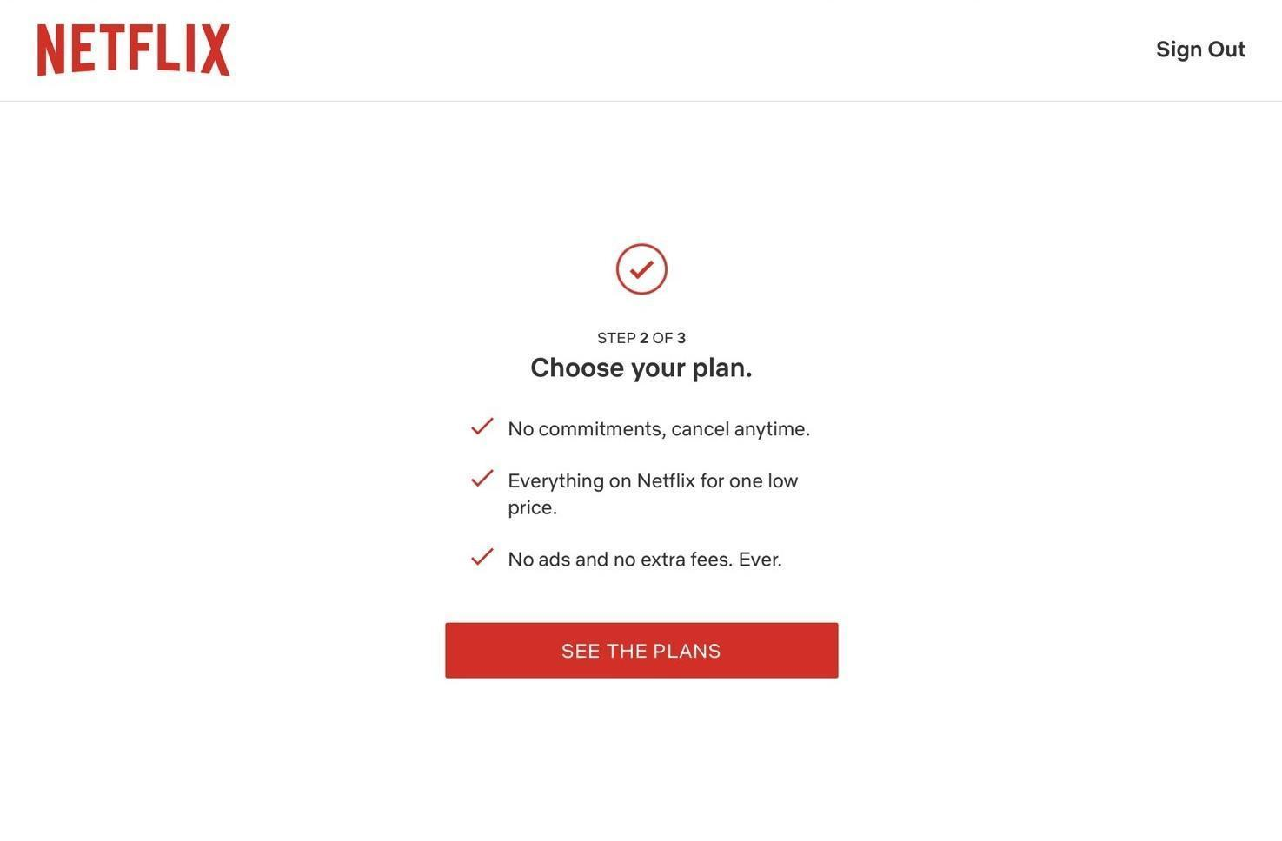

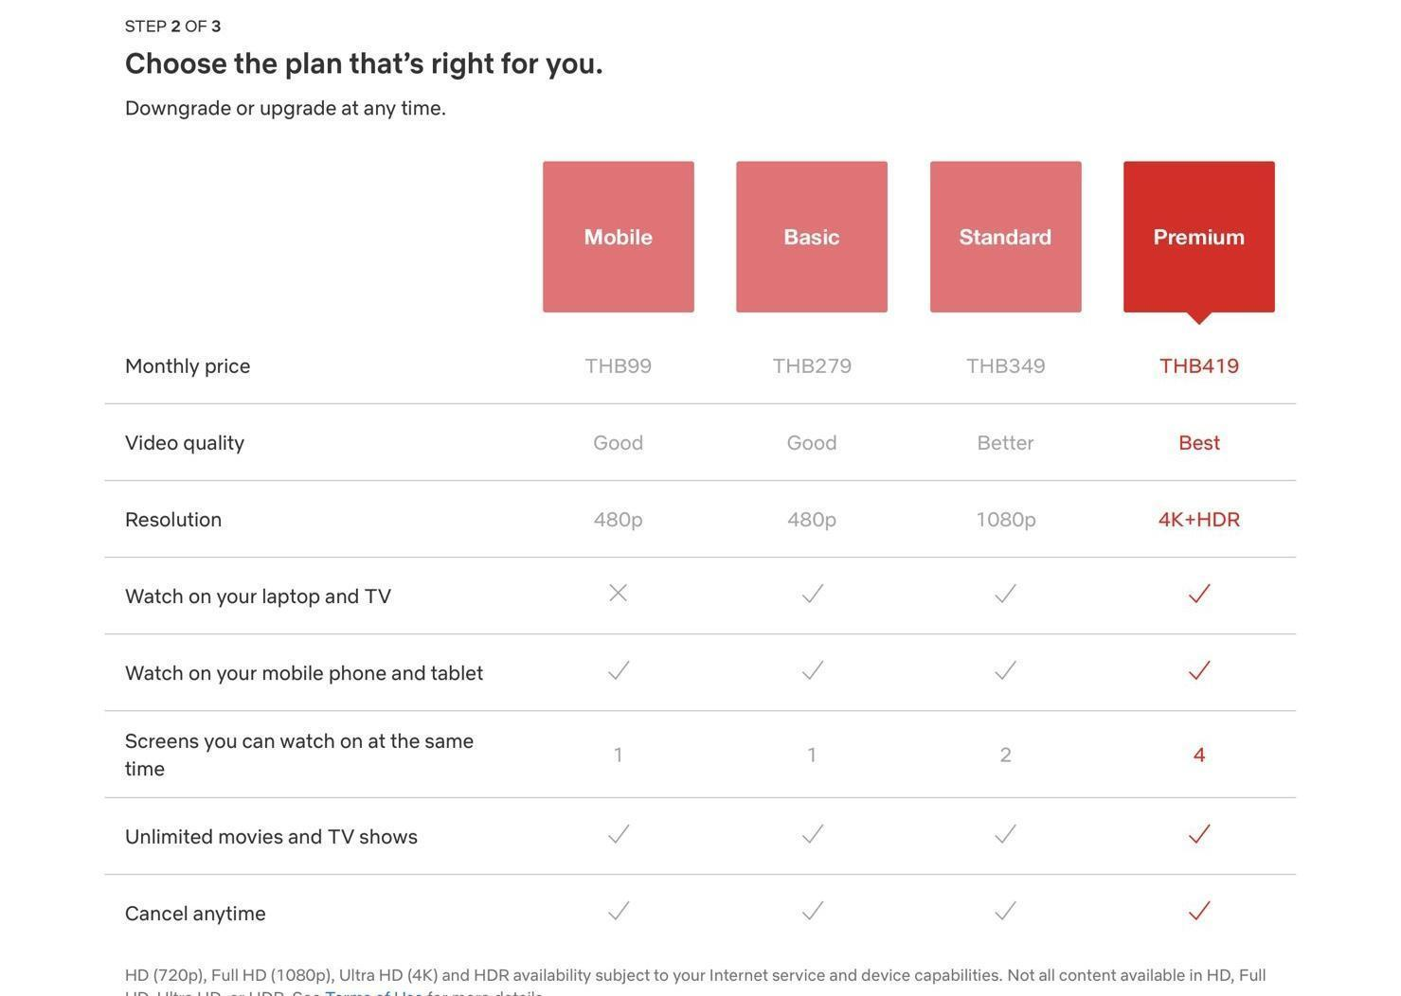

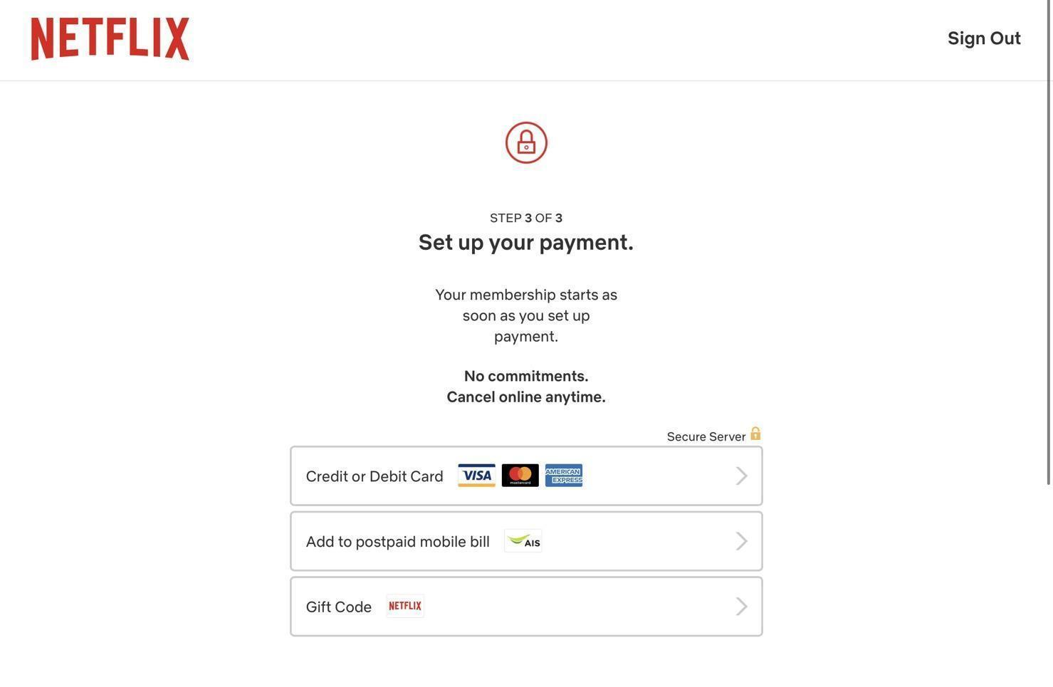

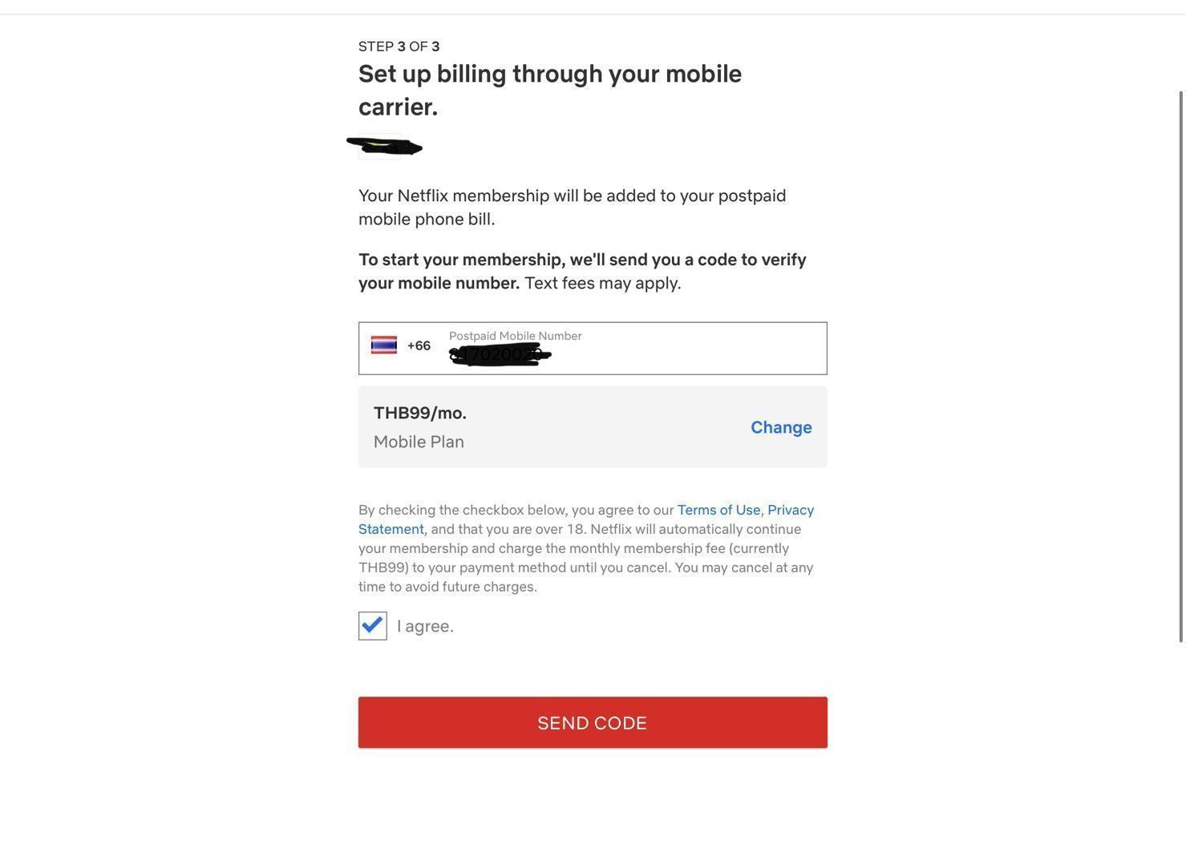

**ERD**

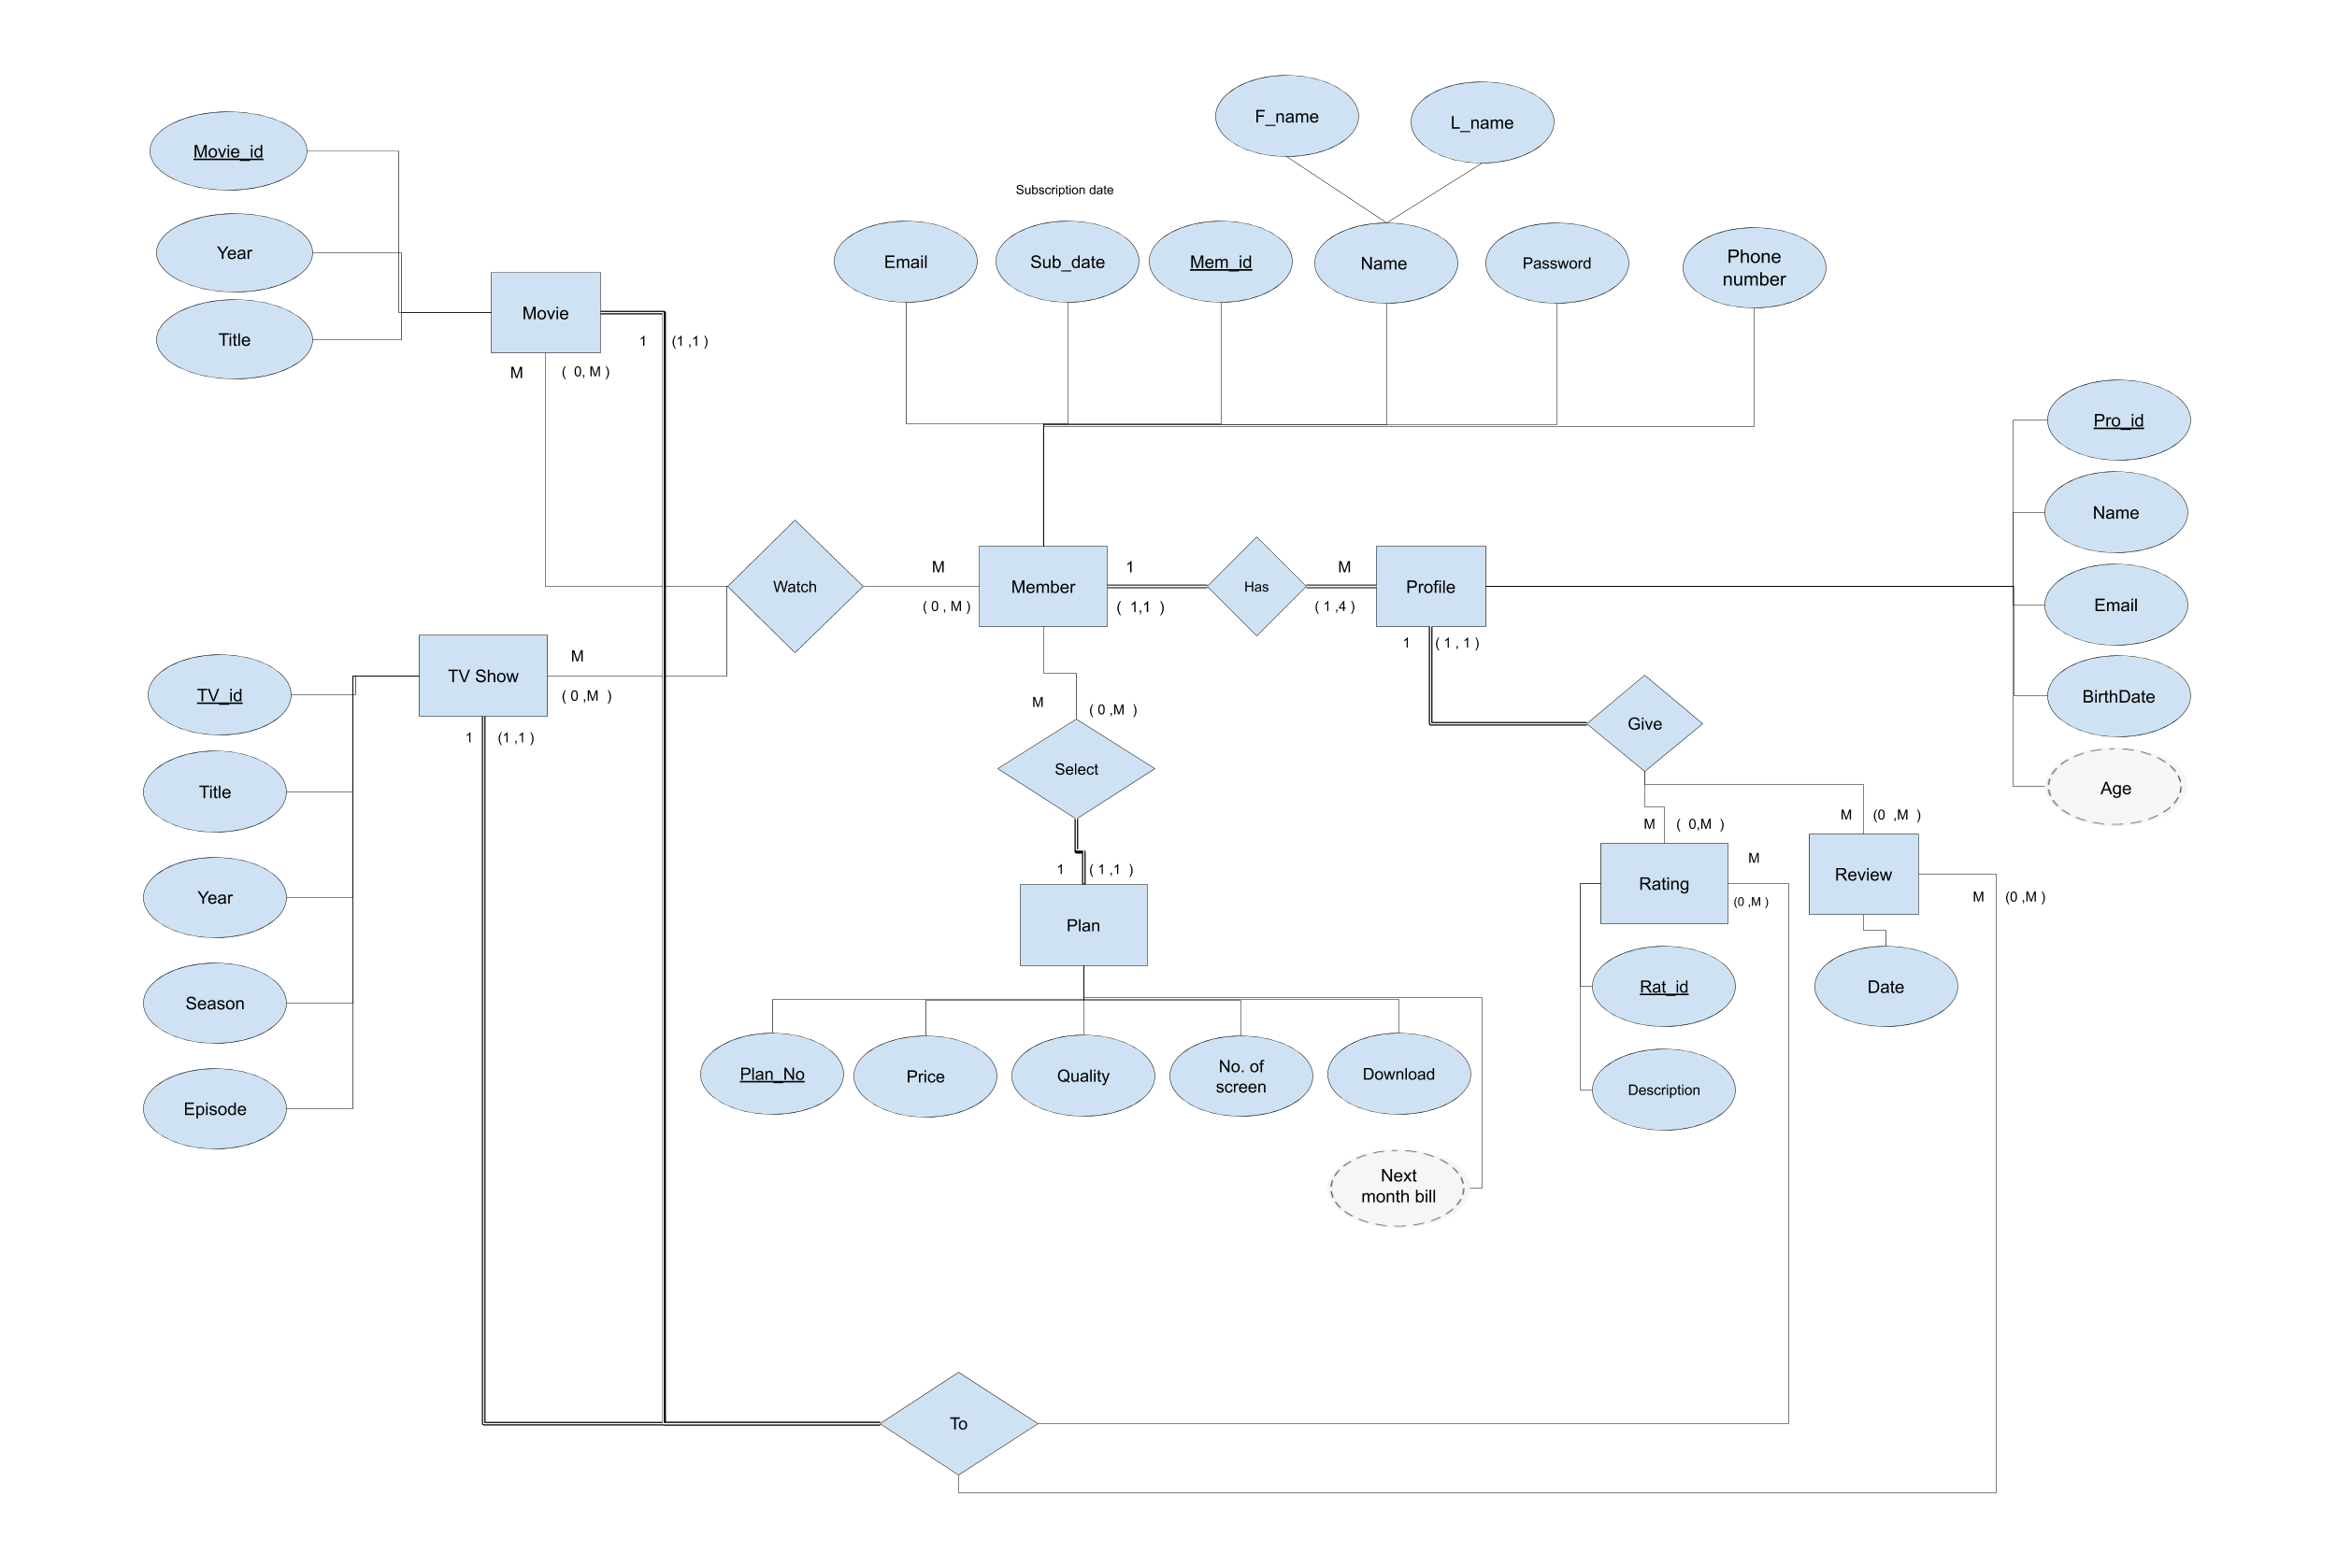

**Relational schema**

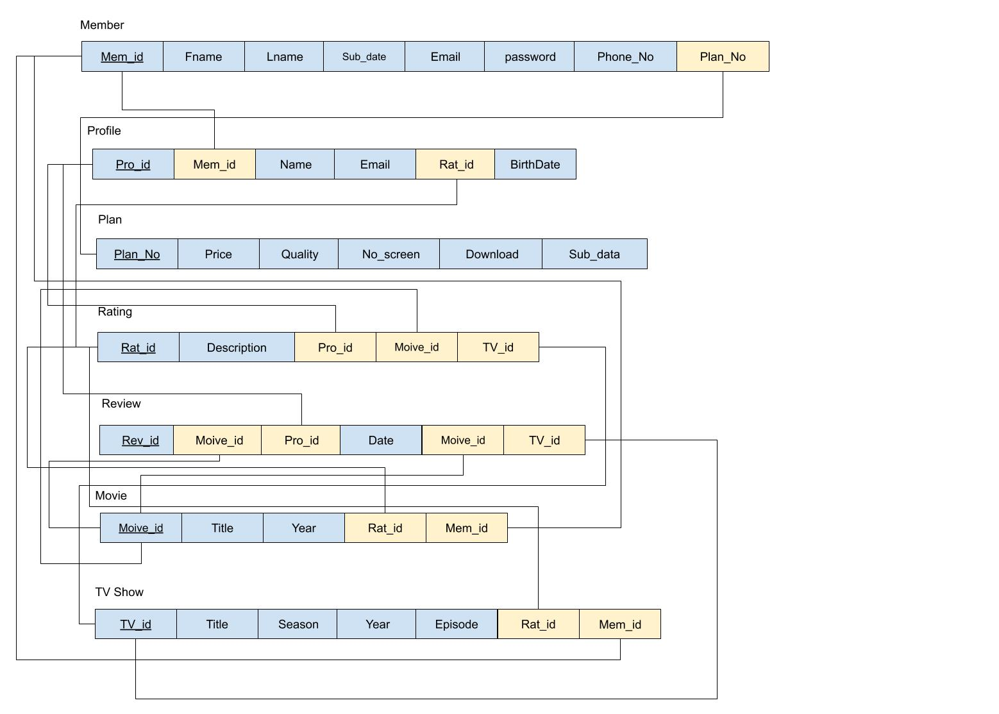

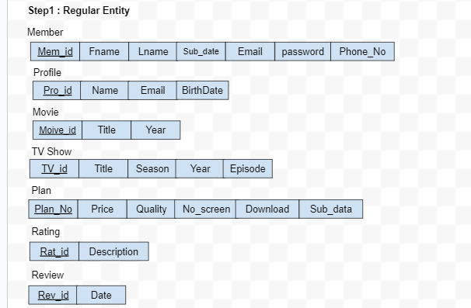

**Data Dictionary**

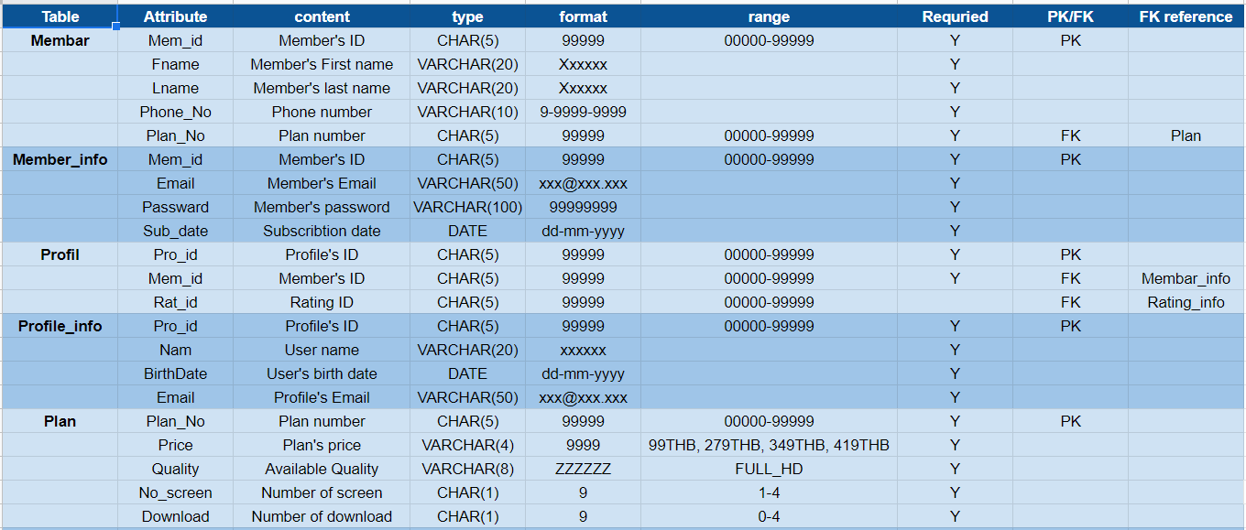

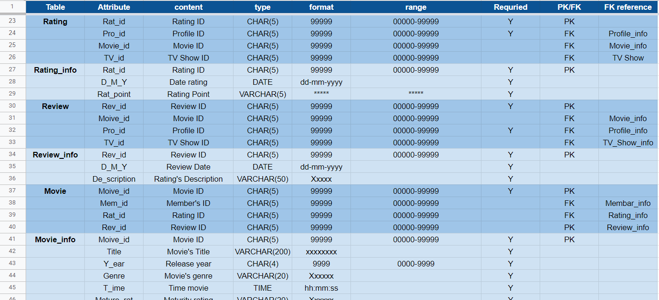

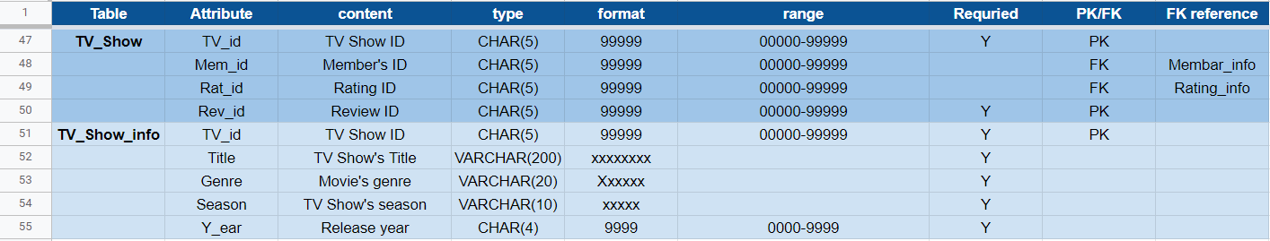

**Query**

Queries to Create, Alter, Drop

1. Create table Member_info

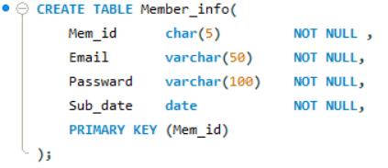

1. Create table Profile_info

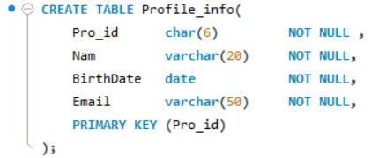

1. Create table Plan

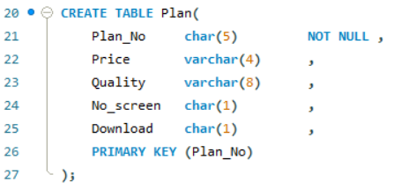

1. Create table Rating_info

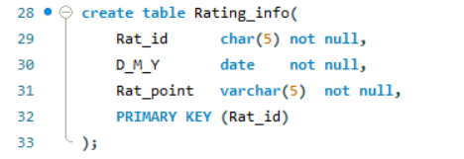

1. Create table Review_info

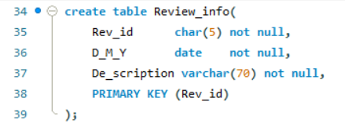

1. Create table Movie_info

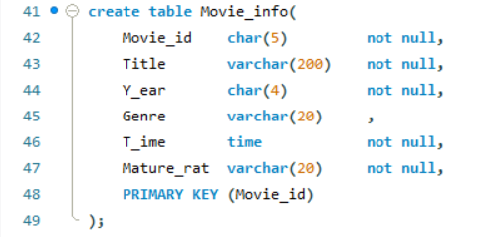

1. Create table TV_Show_info

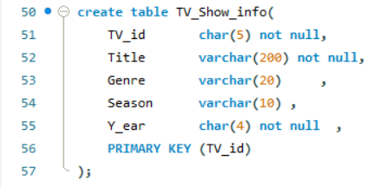

1. Create table Membar

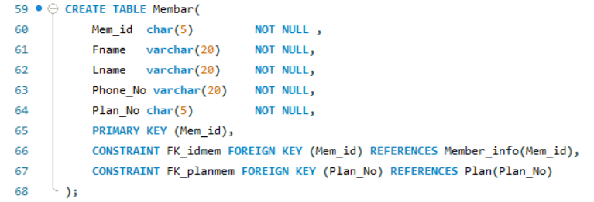

1. Create table Profil

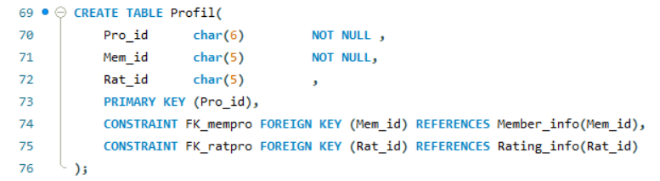

1. Create table TV_Show

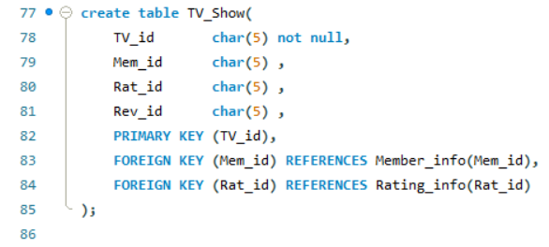

1. Create table Membar

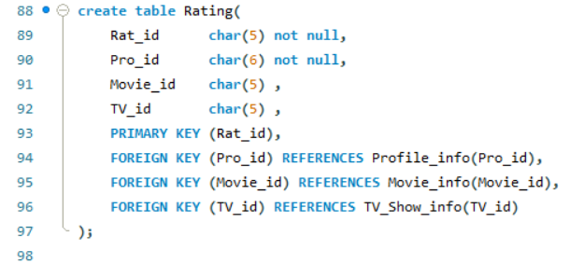

1. Create table Review

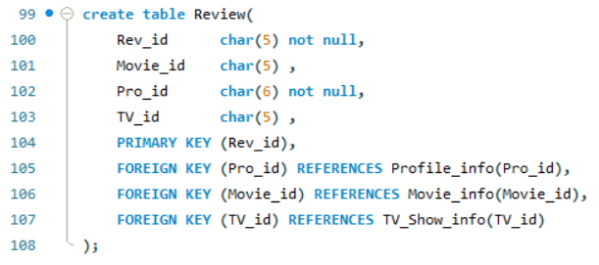

1. Create table Movie

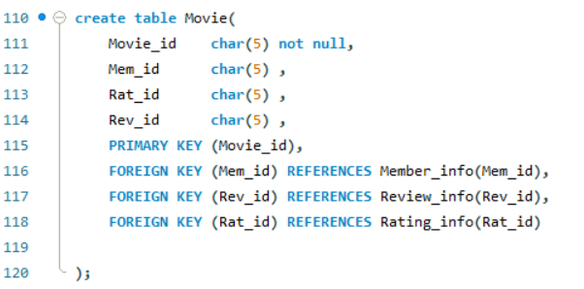

1. Add new column “Type_Color”/“Reserve_Email”/“t_ime”/“mem_id”/“bill” into Profile_info/Member_info/Review_info/Rating/Membar table

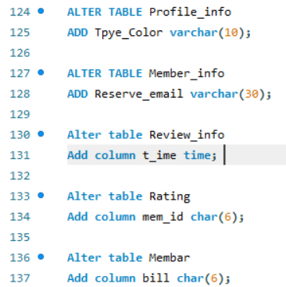

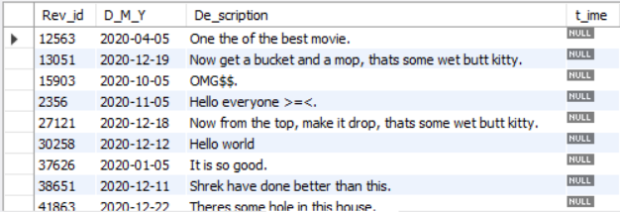

Result in Review_info table

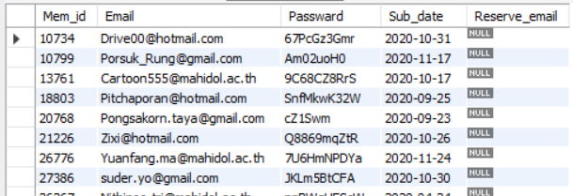

Result in Member_info table

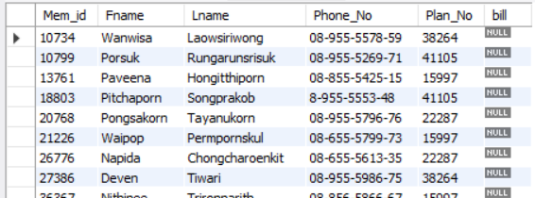

Result in Membar table

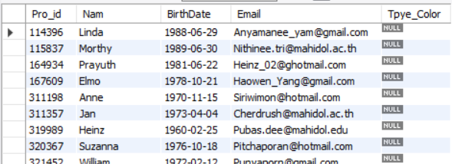

Result in Profile_info table

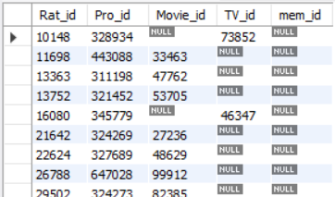

Result in Rating table

1. DROP all of the added column

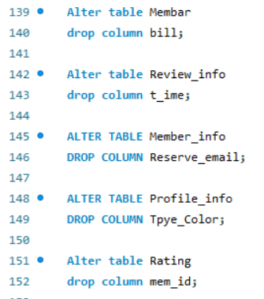

1. DROP Review,Rating,Movie,Profil and Membar table

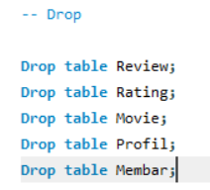

**Queries to Insert, Update, Delete**

Insert, Update, Delete

1. Insert data in Member_info

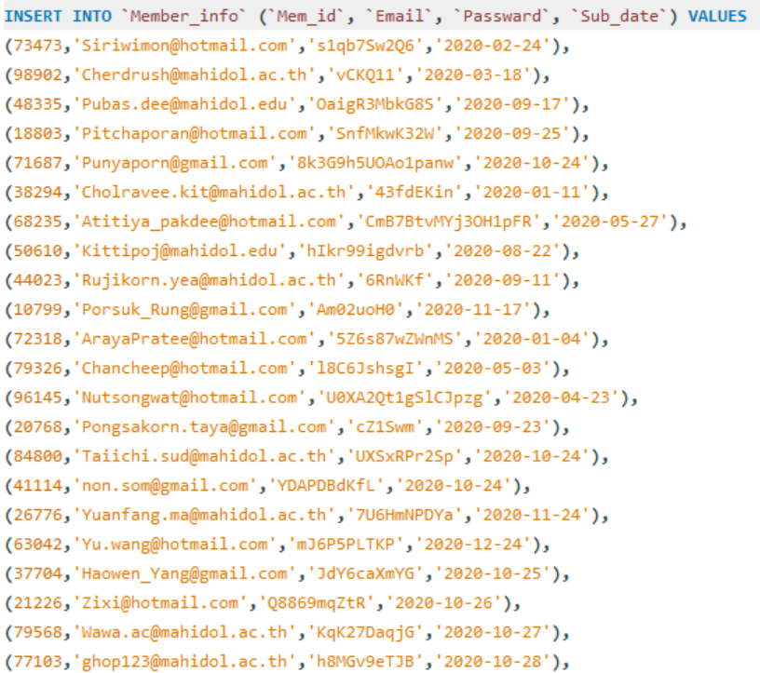

2. Insert data in Profile_info

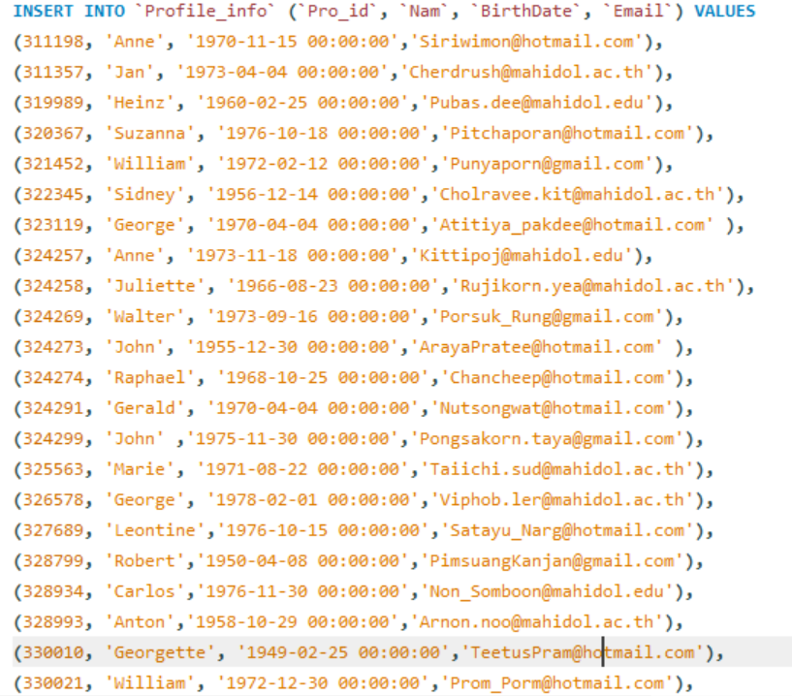

3. Insert data in Plan

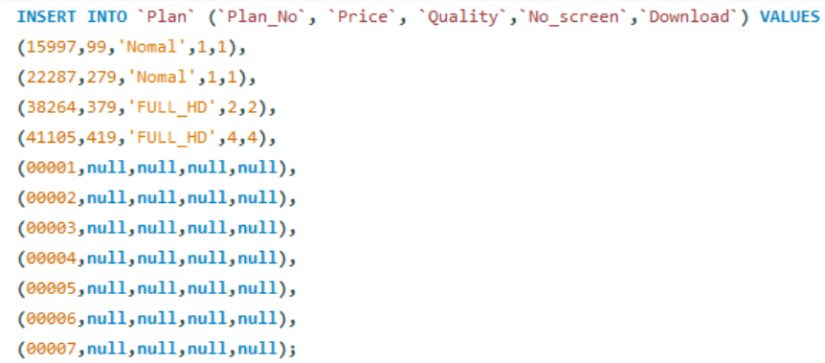

4. Insert data in Membar(Member)

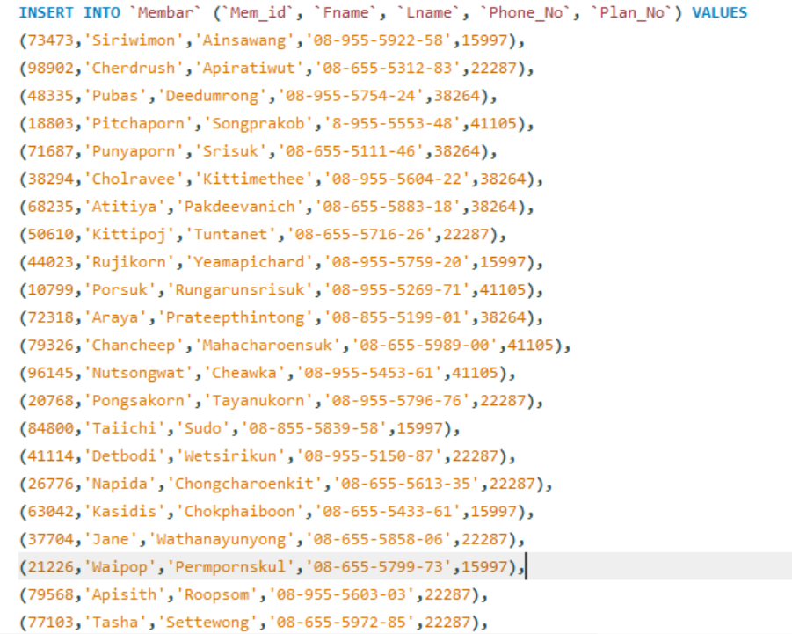

5. Insert data in Rating_info

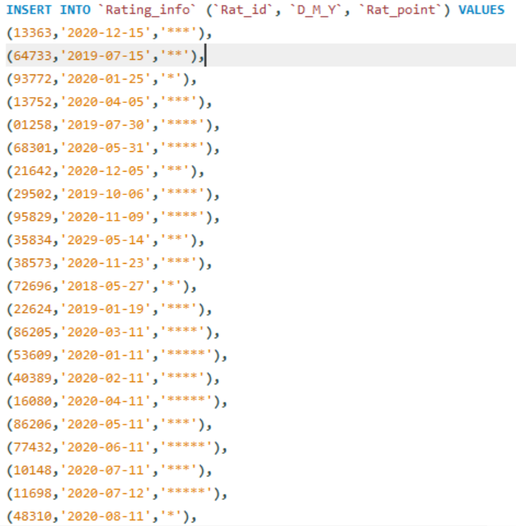

6. Insert data in Profil (Profile)

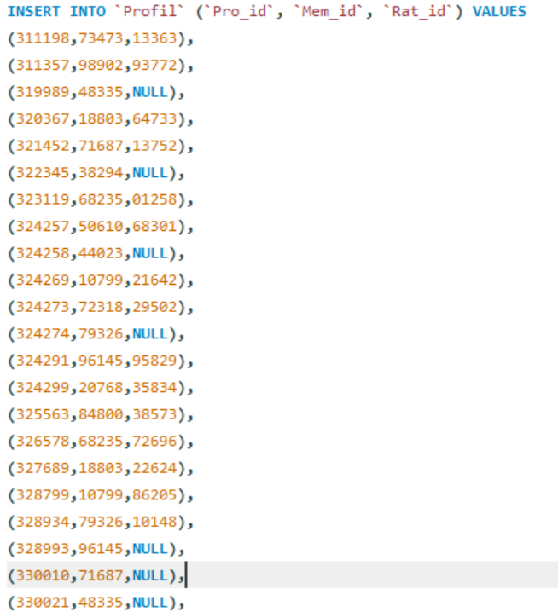

7. Insert data in Review_info

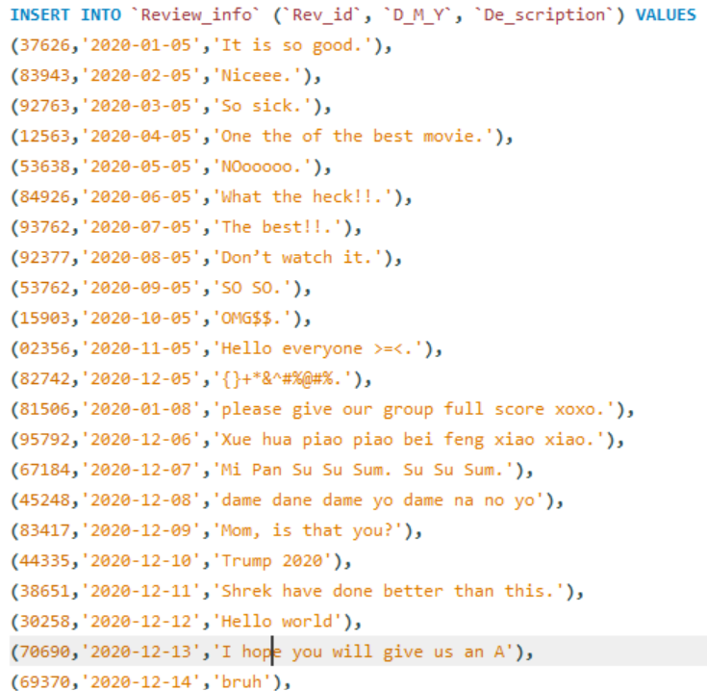

8. Insert data in Movie_info

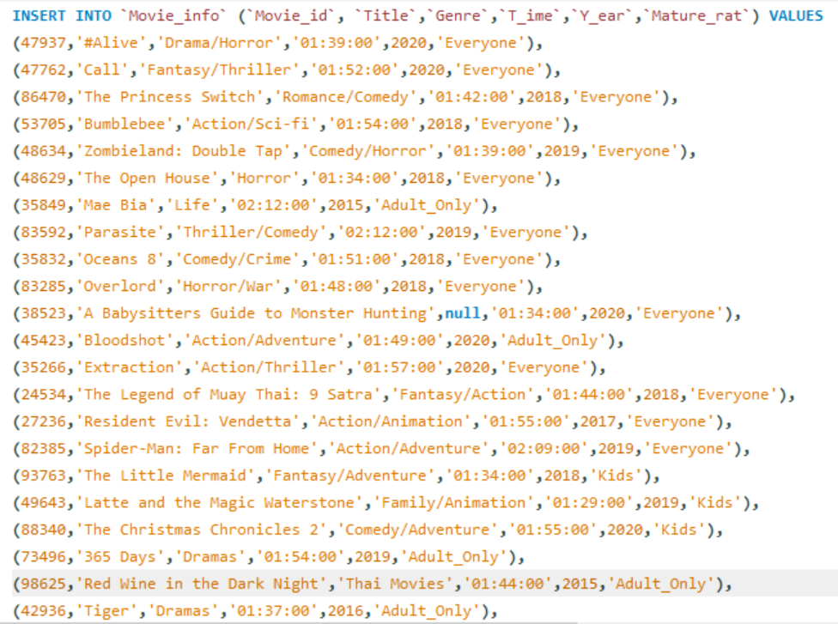

9. Insert data in Tv_Show_info

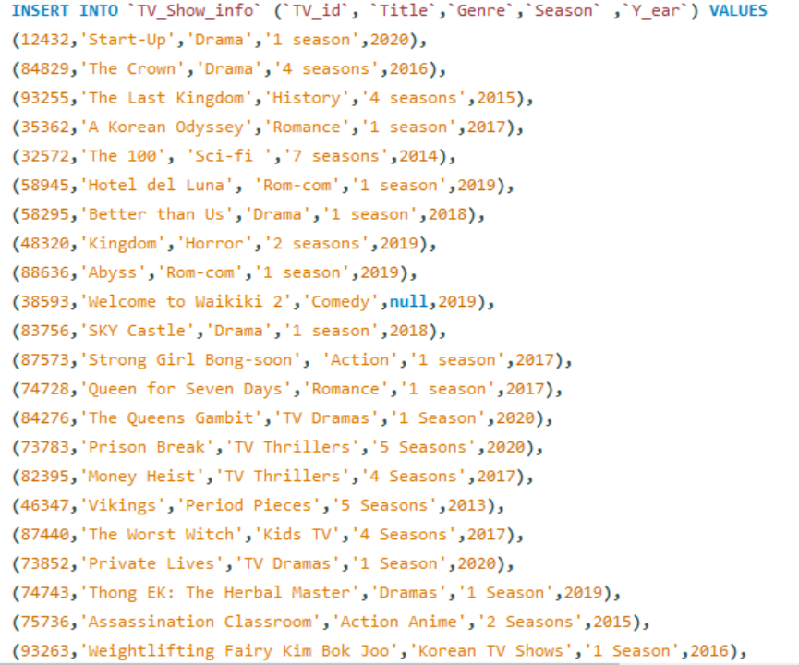

10. Insert data in Rating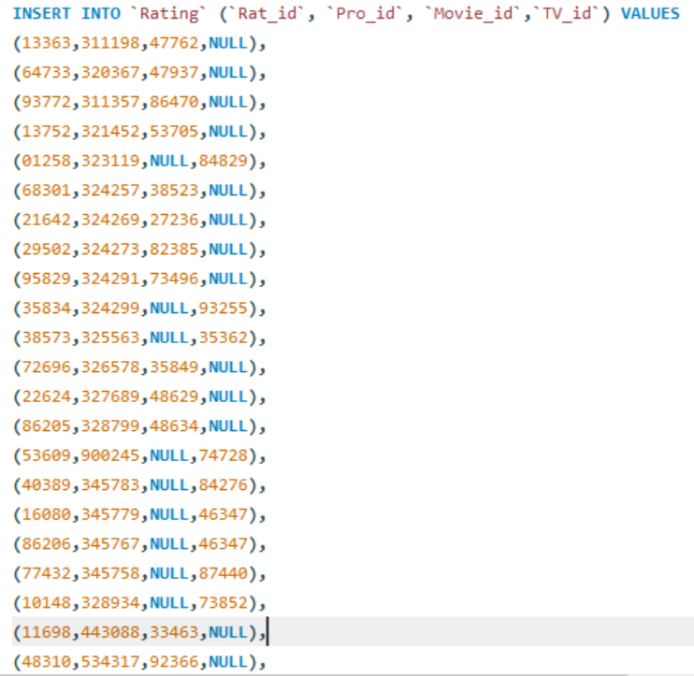

11. Insert data in Review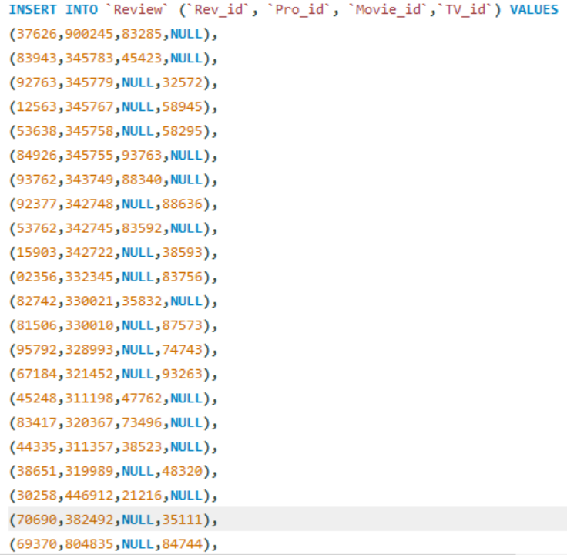

12. Insert data in Movie

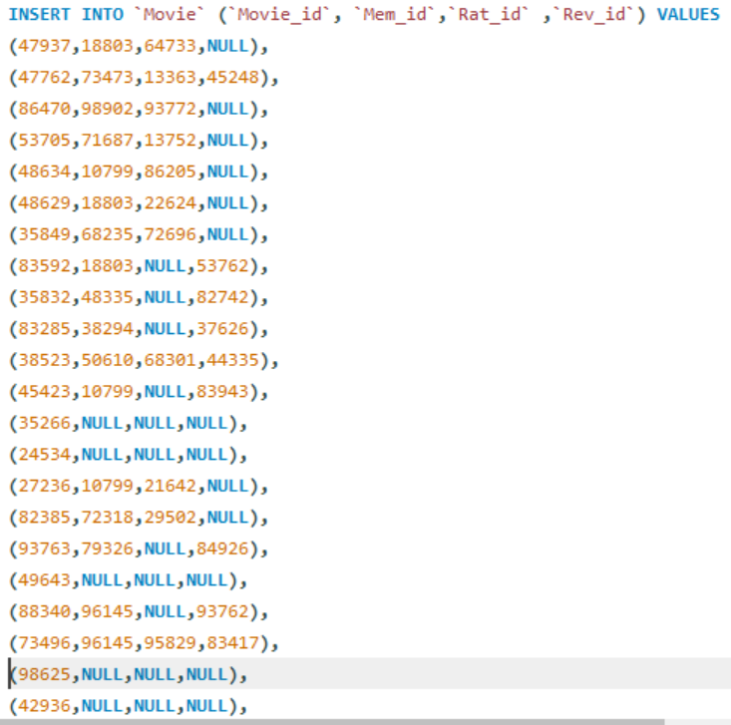

13. Insert data in TV_show

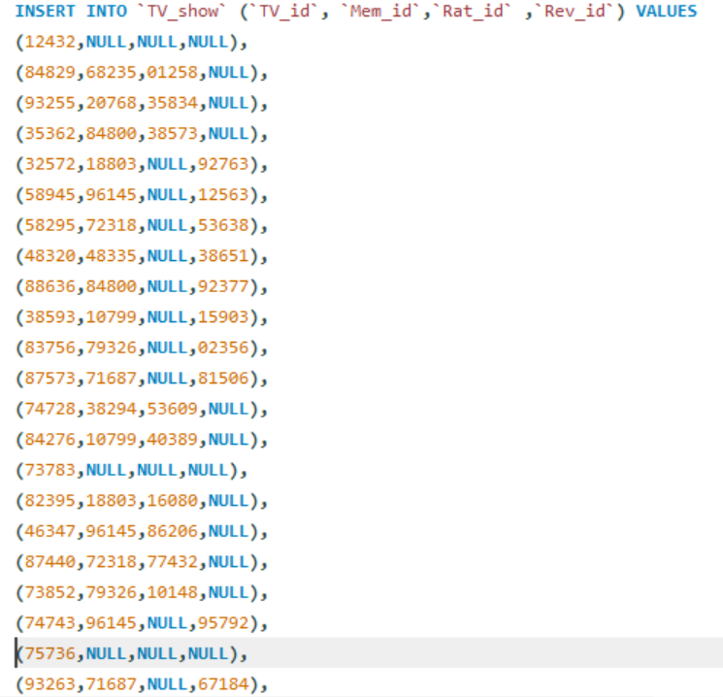

14. Update Review_info and De_scription at Rev_id = 44335

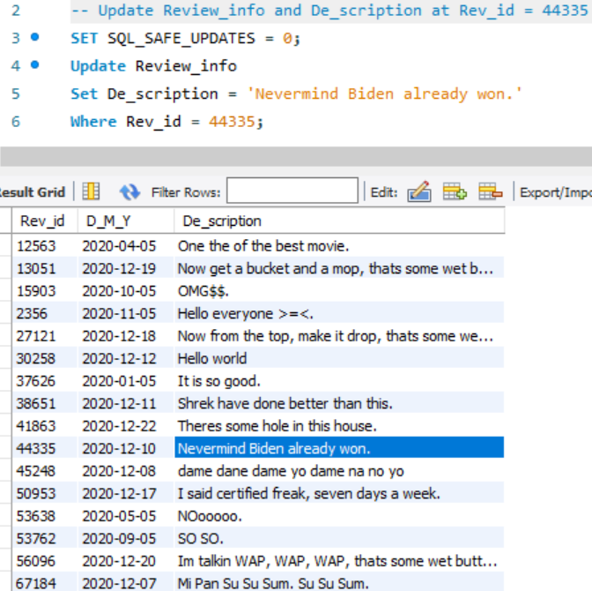

15.Update Rating_info and Rat_point at Rat_id = 72696

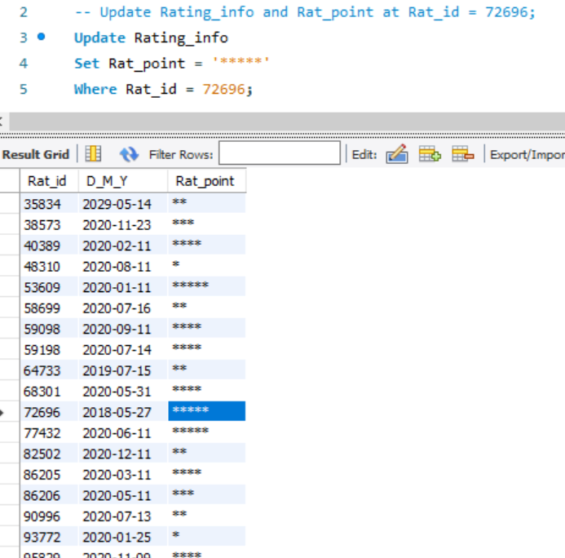

16. Update Profile_info and Nam(Name) at Pro_id = 326578

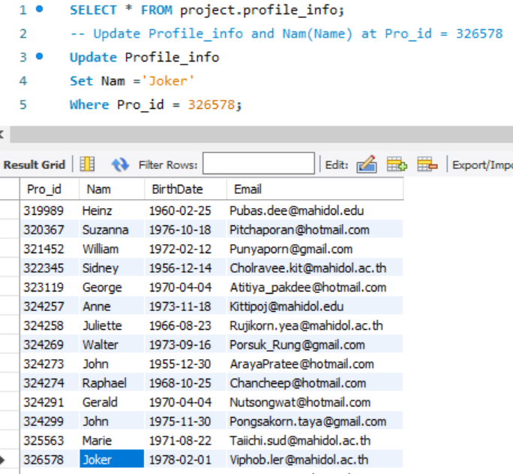

17. Update Member_info and Passward at Mem_id = 21226

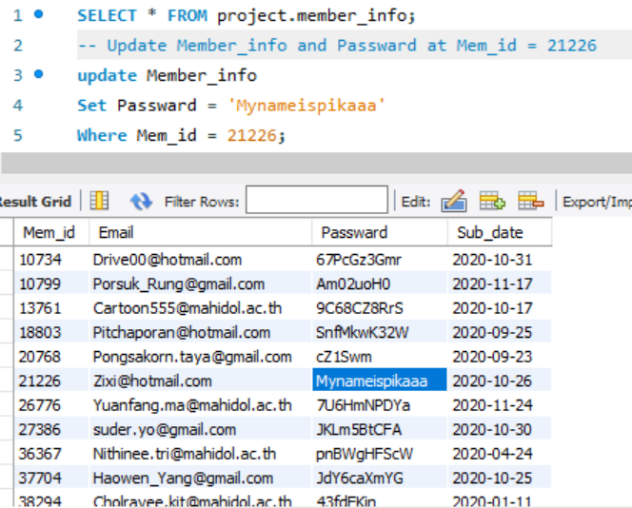

18. Update Profile_info and Email at Pro_id = 164934

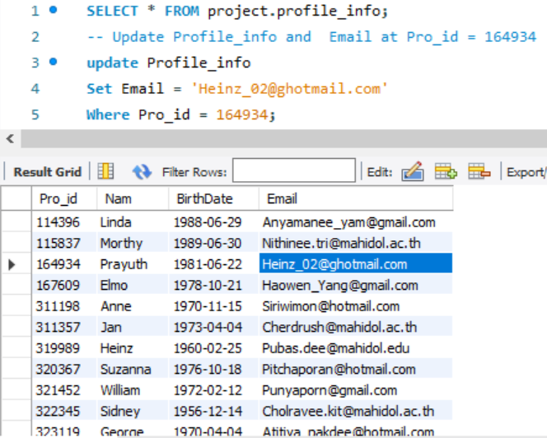

19. Delete Rev_id from Review_info table

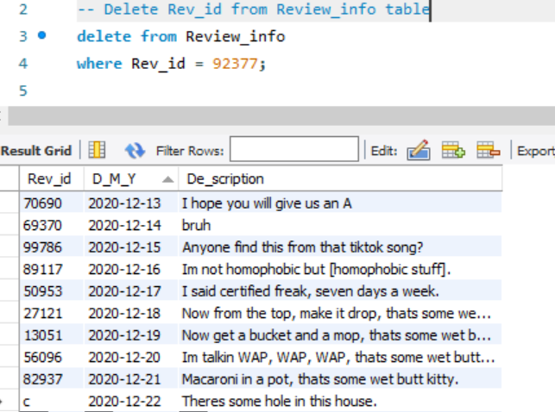

20. Delete Movie_id = 73496 from movie table

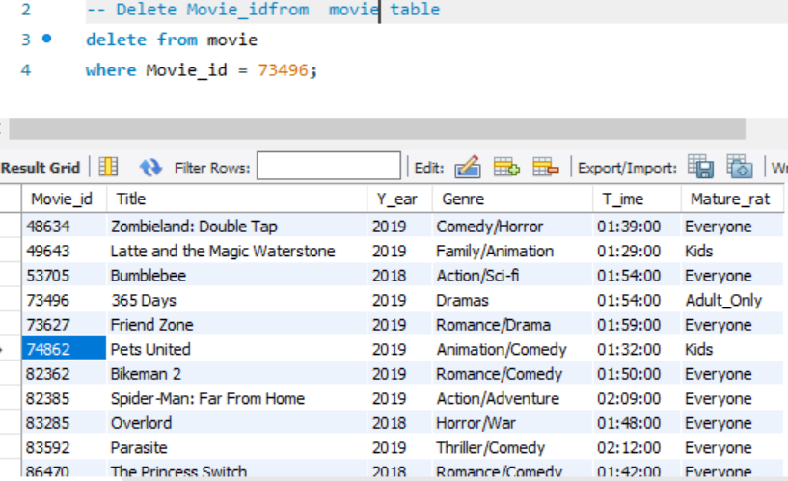

21. Delete Rev_id = 968498,804835 from Review table

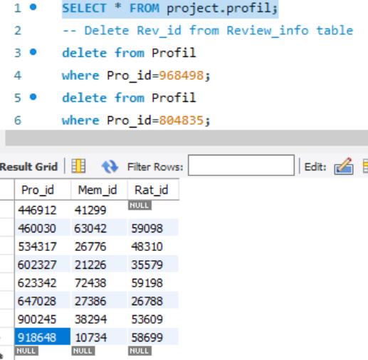

22.Delete Rat_id = 1258 from Rating

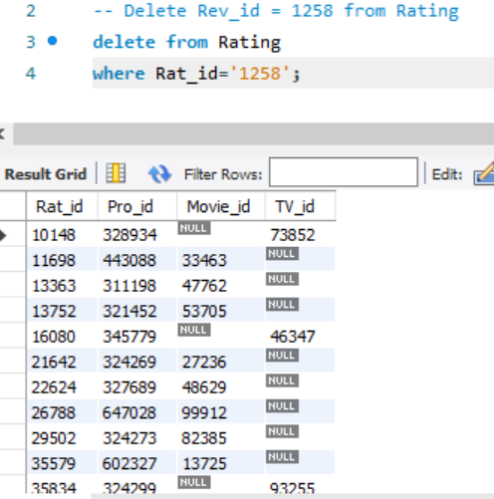

**Basic Queries**

1. list of profile id that have done rating

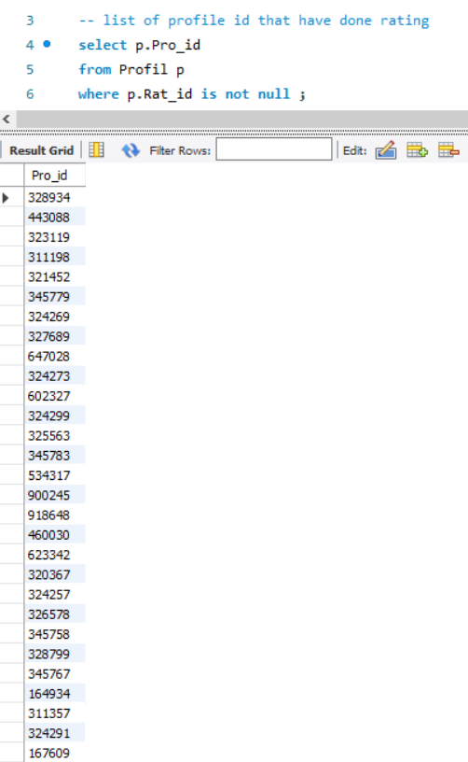

1. list of action movie

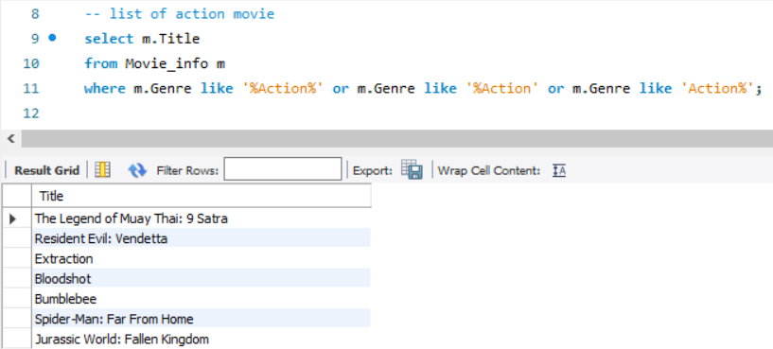

1. list of Member with password longer than 7

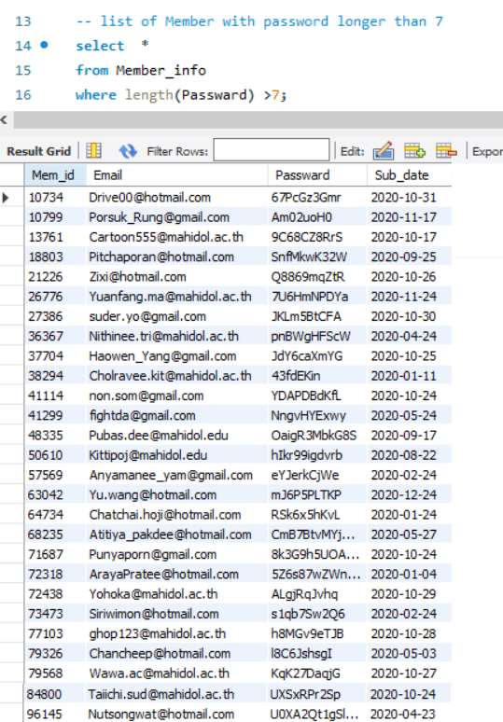

1. list of member who use hotmail

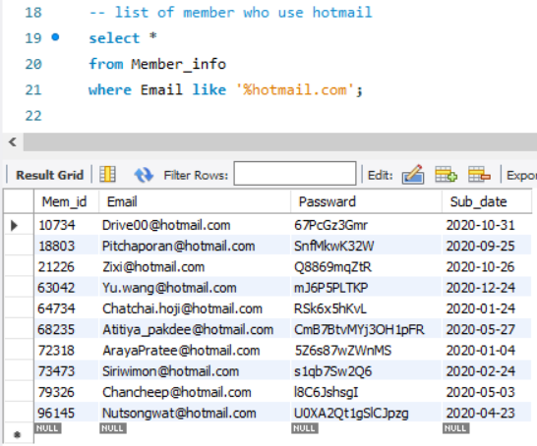

1. list of member who choose plan 1

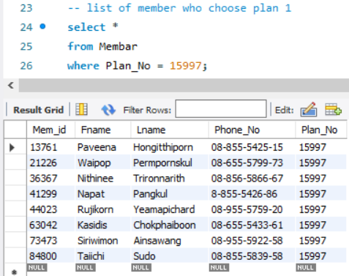

1. list of Review that done in december

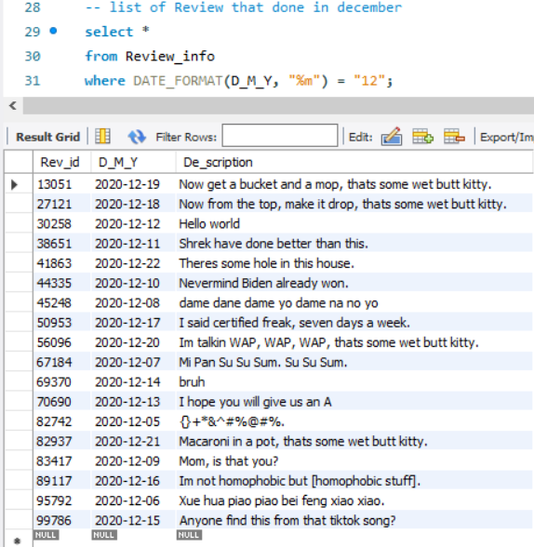

1. list of Movie that release before 2019

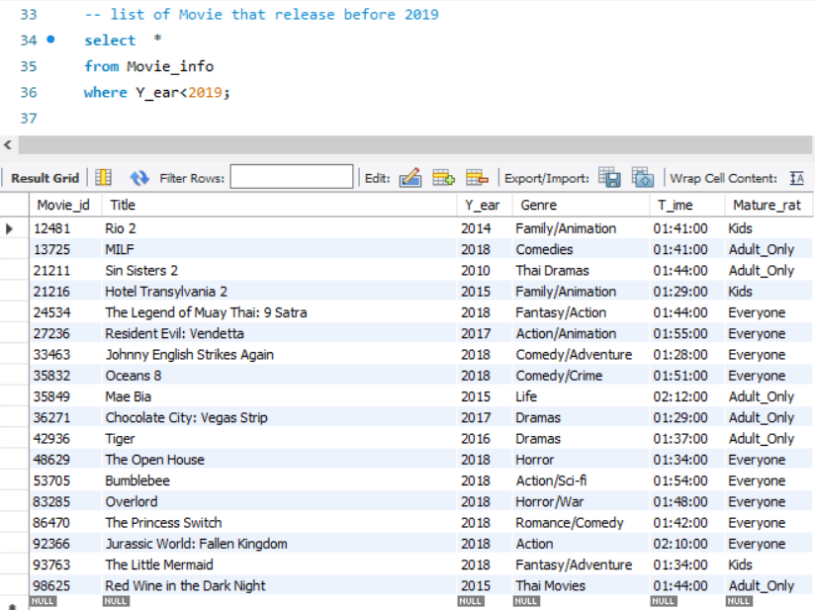

1. list of Tv series with more than 1 season

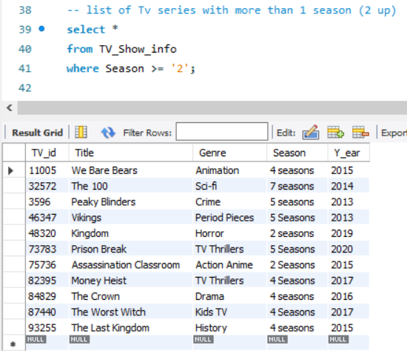

1. list of profile who was born before 1975

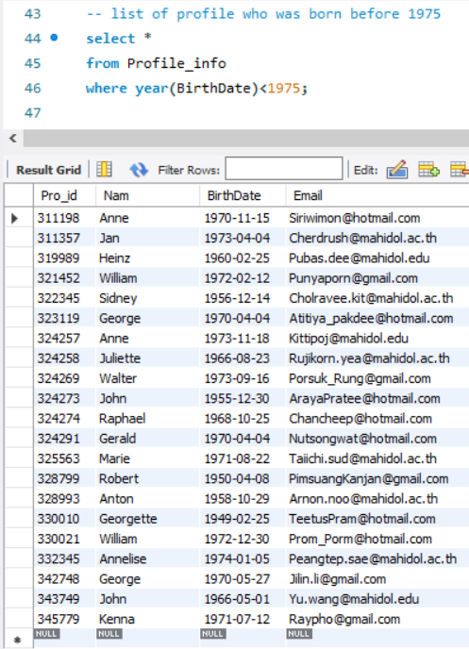

1. list of member who start sub on october

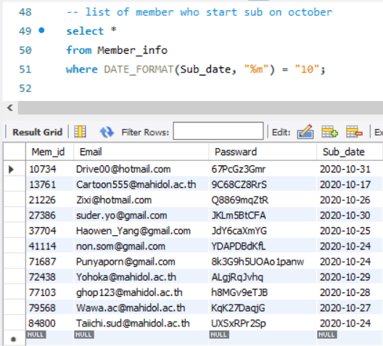

1. Show list of movies in the year 2020

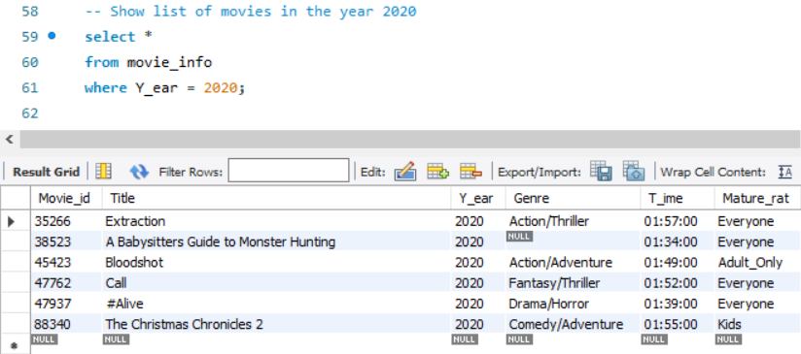

1. Show list of movies in the year 2020

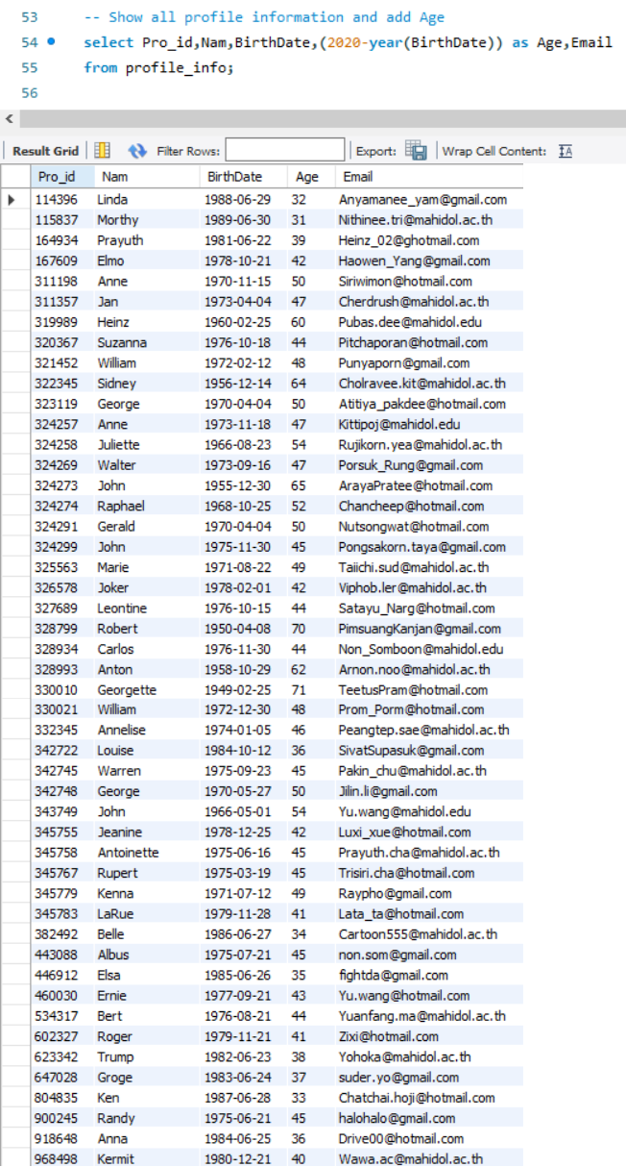

1. Show average age from profile

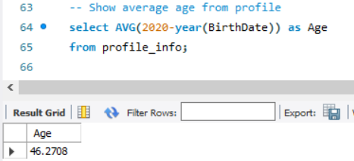

1. Show list of Maturerat from movie for Everyone

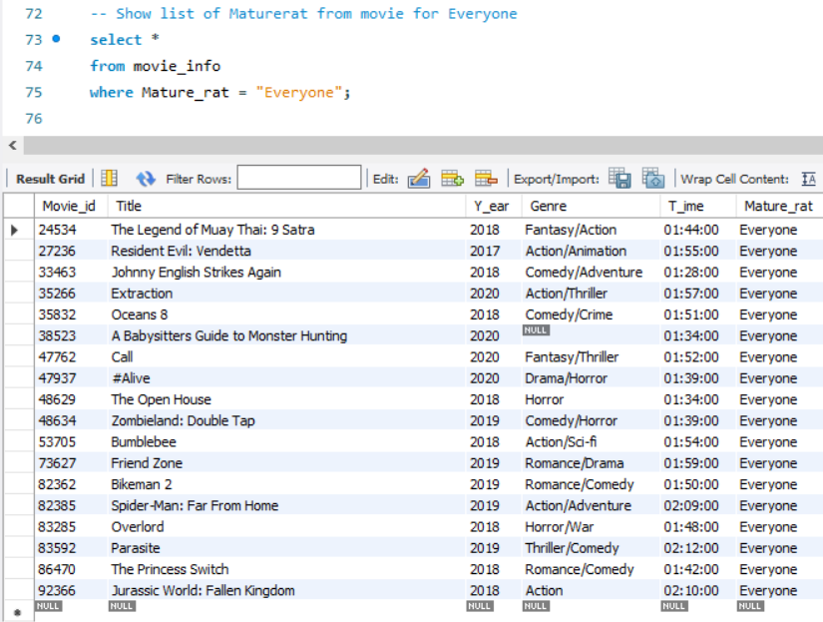

1. Show list of Maturerat from movie for Adult only

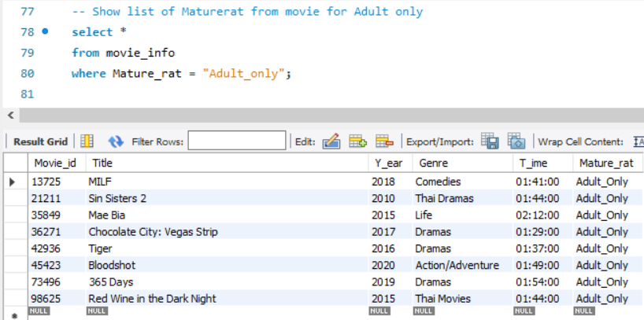

1. Show list of Maturerat from movie for Kids

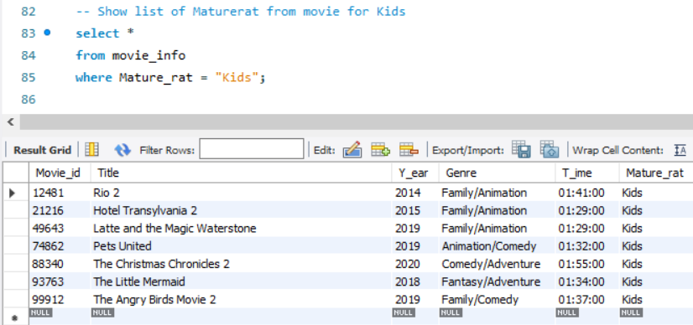

1. Show list of count Mature_rat

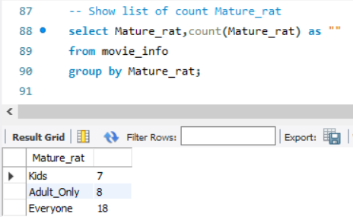

1. Show movie time more than 2 hour

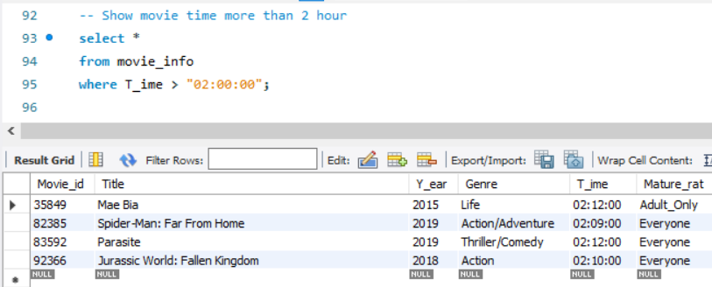

1. Display Member and their next month bill date

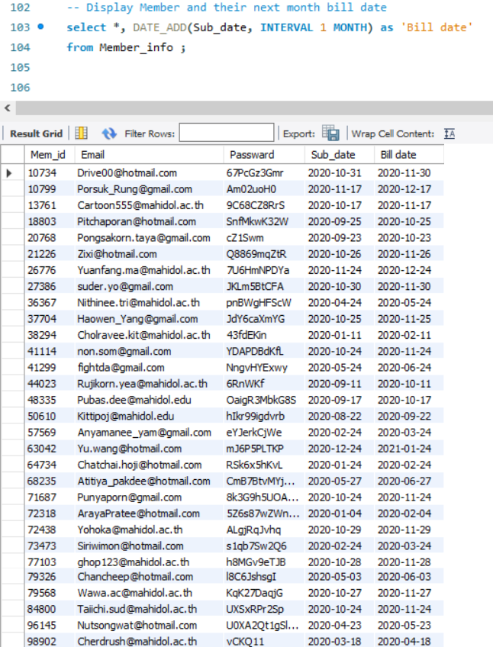

1. Show Name from profile is begin A alphabet 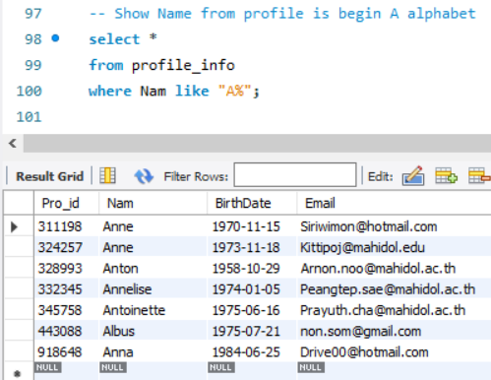

**Advanced Queries**

1. list of movies with its review

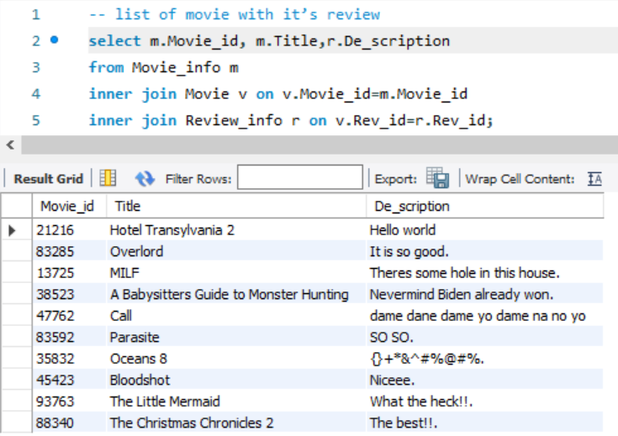

2. list of TV Show with its review



3. list of Member’s bill information

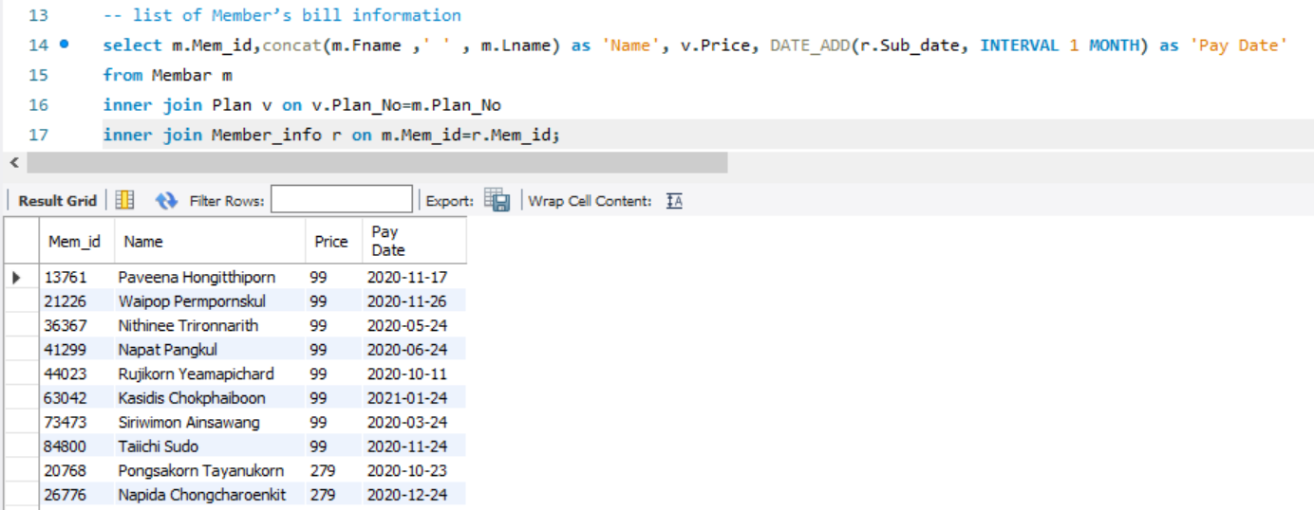

4. List of profiles who pay for the account.

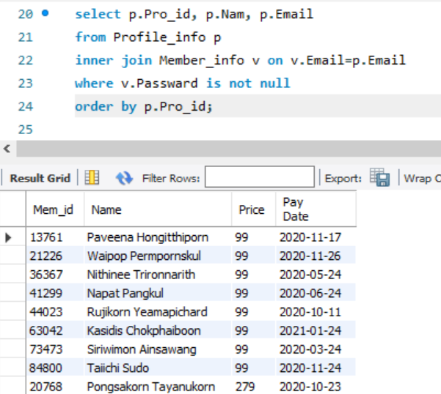

5. list of movies with 5-star rating

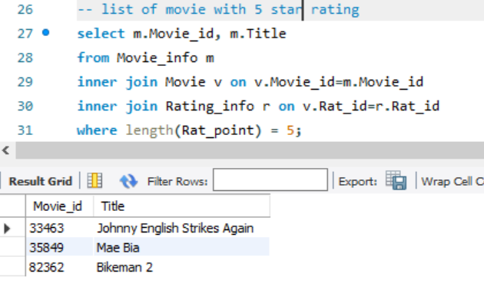

6. List of profile that can watch in full HD

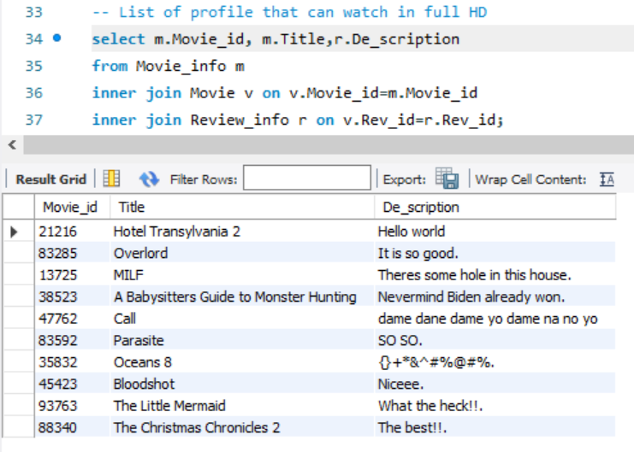

7.Total income per month

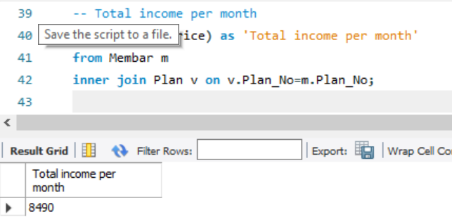

8. List of Comedy movie with more than 2 star

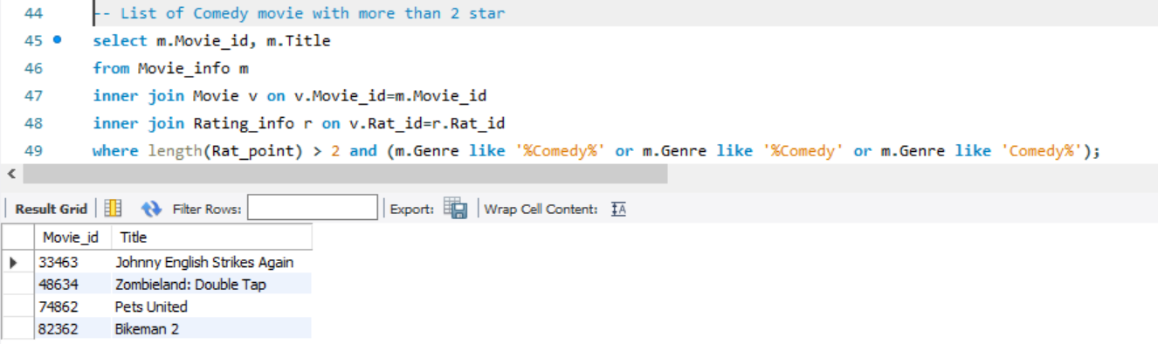

9. List of profile name that never done any rating

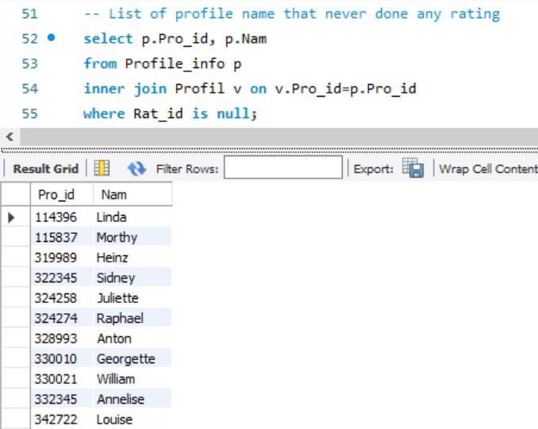

10. List of profiles that do both rating and review and their rating/review.

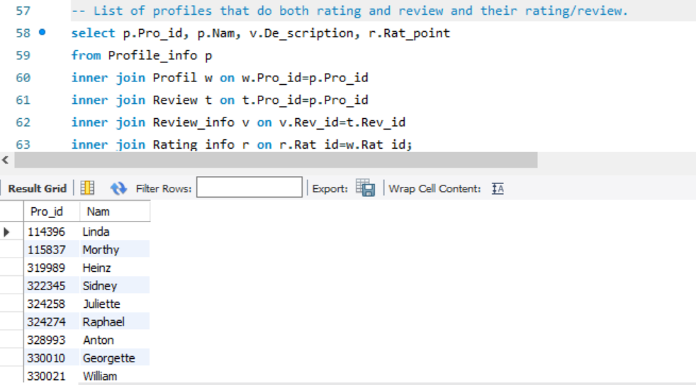

11. Show Tv show with rating

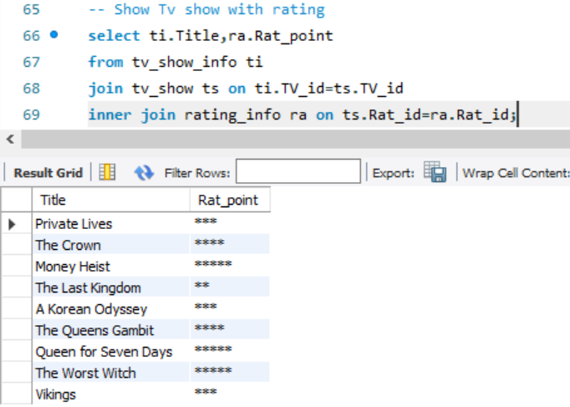

12.Show Movie never get rating

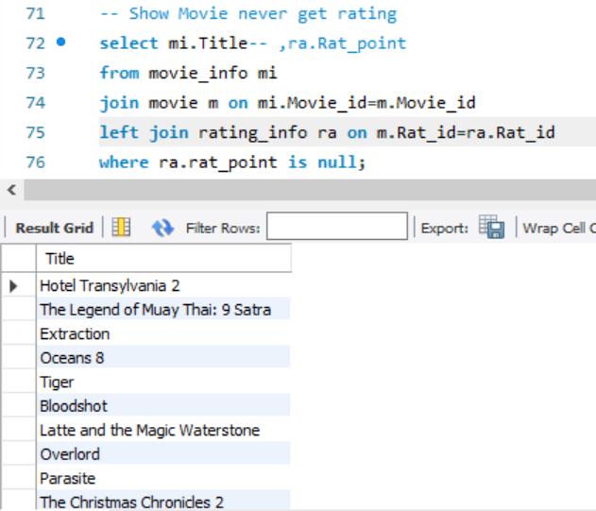

13.Show Member Fname give tv less than 3-star rating

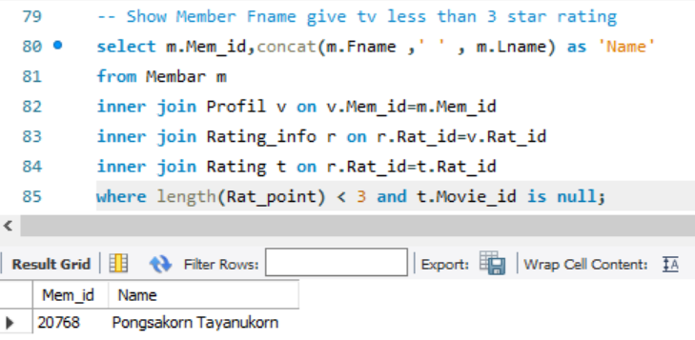

14. Show Member how many can look Number of screens

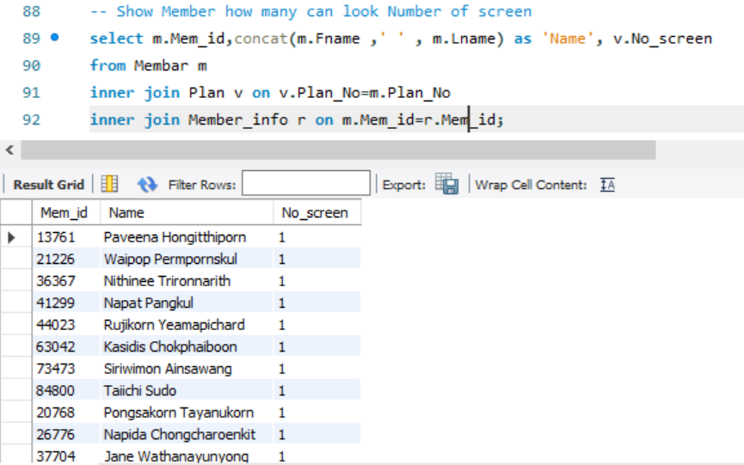

15.Show Movie never get rating

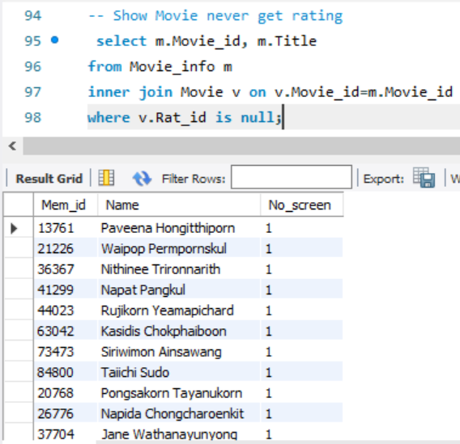

16. Show Tv never get rating

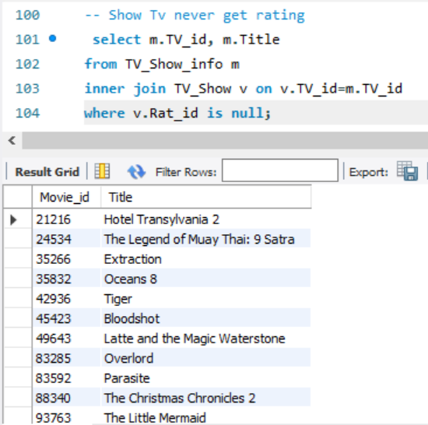

17 Find the Tv Show is less than the Average of movie

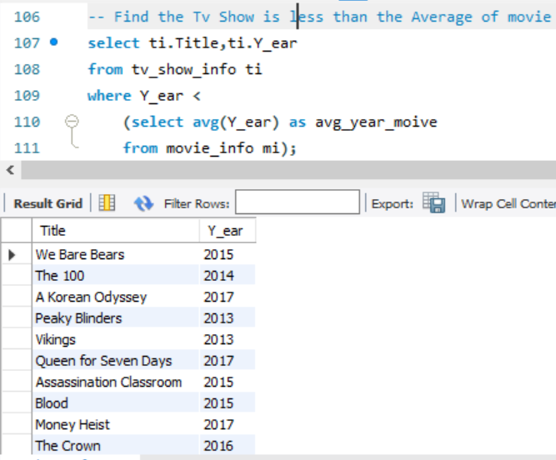

18. Show price of member

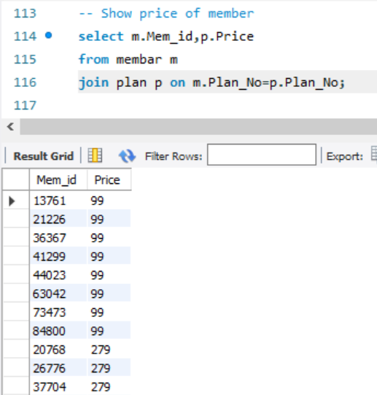

19.Show list of movie rating more than avg rating

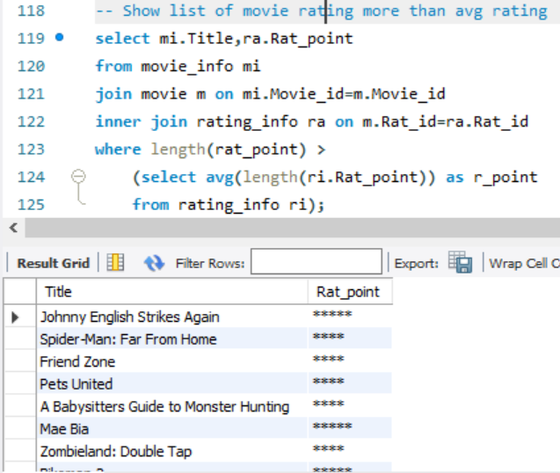

20. Show Email from Member and Profile both begin C alphabet

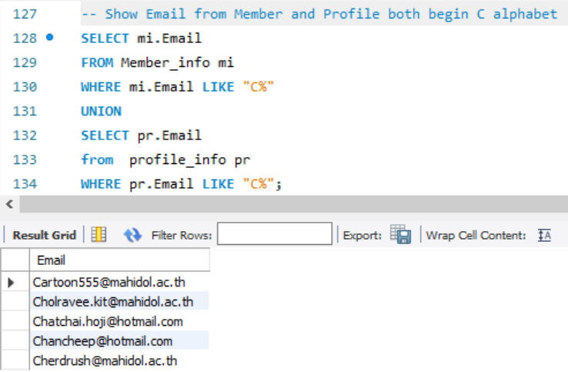

# References

|  |  |
| --- | --- |
| [1] | A. RIVERA, "Rancord Society," Rancord Society, 10 November 2019. [Online]. Available: https://www.rancord.org/netflix-corporate-vision-statement-mission-statement-strategic-analysis. [Accessed 2020]. |
| [2] | G. Cuofano, "How Does Netflix Make Money? Netflix Business Model In A Nutshell," FourWeekMBA, [Online]. Available: https://fourweekmba.com/how-does-netflix-make-money/#:~:text=Netflix%20is%20a%20subscription%2Dbased,licensing%20and%20original%20content%20production. |
| [3] | T. a. a. d. data, "MPAA Rating System," FANDOM, [Online]. Available: https://rating-system.fandom.com/wiki/MPAA_Rating_System. |
| [4] | T. P. Guidelines, "TV Parental Guidelines," FANDOM, [Online]. Available: https://rating-system.fandom.com/wiki/TV_Parental_Guidelines. [Accessed 2020]. |
| [5] | Netflix, "How does Netflix decide maturity ratings?," Netflix, [Online]. Available: https://help.netflix.com/en/node/2064/th. [Accessed 2020]. |
| [6] | "GUIDE TO RATINGS," Filmratings, [Online]. Available: https://www.filmratings.com/RatingsGuide. [Accessed 2020]. |
| [7] | Motion Picture Association,National Association of Theatre Owners, "CLASSIFICATION AND RATING RULES," Motion Picture Association,National Association of Theatre Owners, 24 July 2020. [Online]. Available: https://www.filmratings.com/Content/Downloads/rating_rules.pdf. |